Introduction

Lesson Introduction





### **What We Will Cover In This Lesson**

Nice to see you again. This lesson will focus on Agile Frameworks, with the topic being covered as follows:

* Introduction to Agile Frameworks in general and what the advantages are of using a framework.
* The Scrum Framework and its unique characteristics as a valuable Framework.
* The more lightweight Kanban Framework and its unique advantage in managing flow and WIP
* The XP Framework and its advantages, with an appreciation for its more stringent best practices.

### **By the End of the Lesson You Will Be Able To...**

* Identify the advantages of using a framework
* Identify the specific and shared characteristics of Scrum, Kanban, and XP frameworks
* Determine which frameworks are appropriate for a given project
* Identify the core team roles assign team members to each role
* Implement best practices for each framework, including ceremonies and artifacts



What We Will Cover In This Lesson

# Why Agile Frameworks?

## Why Do Agile Frameworks Matter?













### **Agile Frameworks Are A Vehicle for Practically Utilizing Agile**

Agile's principles related to simplicity, adaptability, and the ability to embrace change attract attention. For Agile to practically be utilized effectively, an Agile Framework, or a combination of frameworks, is usually adopted.

### **Similarities Between Agile Frameworks:**

* Adhere to the Agile Mindset as being fundamental to the success of any Agile journey
* Emphasize that being Agile is critical to successfully doing Agile
* The Agile Manifesto’s 4 paired core values and its associated 12 guiding principles set the foundation for all Agile Frameworks
* Provide guidance on how to bring the Agile Manifesto’s core values and principles to life







### **Additional Resources**

* [**The Best Framework to Use for a Successful Agile Transformation(opens in a new tab)**](https://www.projectmanagement.com/blog-post/62476/The-Best-Framework-to-Use-for-a-Successful-Agile-Transformation): In this blog post, Al Shalloway walks through the value of Agile Frameworks.

# How Experts Approach Agile Frameworks

## Thinking About Agile Frameworks





















### **Agile Frameworks are Enablers that Bring to Fruition the Value of Agile**

This includes:

* Focusing more on the individuals and interactions; ultimate determining factor for the success of a product are the resources on the Agile product delivery team.
* Do not force Agile unnecessarily; Teams that are already performing well can be gradually introduced to additional Agile practices based on a specific Agile Framework.
* Refined user stories are important; Agilists work with Product Owners to ensure the user stories have been sufficiently refined for the Agile Team to proceed.
* Respect the backlog; Agilists focus on ensuring the Agile Team does not over-commit to what can be accomplished in each iteration, especially during the first few iterations.

### **Implementing a Specific Agile Framework is a Fine Balancing Act**

* Must adapt based on each organization’s unique culture and context.
* Experts have to regularly remind both leaders and the Agile Team to remember that there is no one way to execute Agile practices in an organization.
* Agile principles and practices are by their very nature to be adapted as needed.



Framework “Balanced” with Organizational Context







### **Additional Resources**

* [**Advanced Topics in Agile Planning(opens in a new tab)**](https://www.mountaingoatsoftware.com/presentations/advanced-topics-in-agile-planning): In this presentation, Mike Cohn walks through Advanced Agile Planning.

# Agile Frameworks

## What Are Agile Frameworks?

















### **Agile is an Umbrella Term for a Variety of Frameworks that Align with The Agile Manifesto**

Every Agile team's goal is to deliver value-driven functionality with built-in quality and to do it quickly. This is where **Fail Fast and Learn** is priceless. Agile teams who wish to deliver both amazing product features that delight customers, as well as do it fast, must learn to quickly change course when it is realized that a product feature is heading down the wrong path.

### **The Agile Umbrella**

The Agile Umbrella has some key characteristics:

* **Deliver Value**: An absolutely key driver behind anything Agile is to deliver value.
* **Continual Improvement**: Agile promotes incremental improvement to minimize resistance from all who are involved.
* **Flexibility**: Flexibility is one of the foundations of any Agile Framework.
* **Trust and Respect**: Agile Frameworks promote trust and respect because such trust and respect motivate Agile teams.
* **Cultivate Mastery**: This built-in structure for Agile team members to hone their skills further motivates the Agile team.



The Agile Umbrella

### **New Terms**

* **Agile Umbrella**: A term that refers to the various Agile Frameworks that follow the Agile Manifesto's values and principles

### **Additional Resources**

* [**Five Powerful Enterprise Agile Frameworks(opens in a new tab)**](https://dzone.com/articles/five-powerful-enterprise-agile-frameworks-1): In this blog, Prabhu Arumugham walks through five Enterprise Agile frameworks that act as process 'blueprints' providing a set of Agile practices, organizational structure, roles, and other recommendations.

# Quizzes: Agile Frameworks

## Thinking About Agile Frameworks







Exercise: Agile Frameworks

The Benefits of Agile Frameworks for SocialKare.gov

How would SocialKare.gov benefit from using an Agile Framework? Review the [**SocialKare.gov Case Study(opens in a new tab)**](https://video.udacity-data.com/topher/2020/September/5f5f6bc7_agnd-c1-foundations-of-agile-socialkare.gov-case-study/agnd-c1-foundations-of-agile-socialkare.gov-case-study.pdf) and identify at least three benefits of using an Agile Framework at SocialKare.gov. Explain how those benefits will help SocialKare.gov be more effective in reaching its goals.







# Solution: Agile Frameworks

## My Solution





### **Identify Three Benefits of Using an Agile Framework**

SocialKare.gov will benefit from:

* Years of experience that a proven Agile Framework has been built upon and further refined over time at many organizations globally.
* By using a proven framework, there’s a higher level of predictability for SocialKare.gov.
* SocialKare.gov will benefit from higher quality product delivery.
* An Agile Framework allows for customizing and adapting the Framework to better align with the organization.





# Scrum

## What Is Scrum?

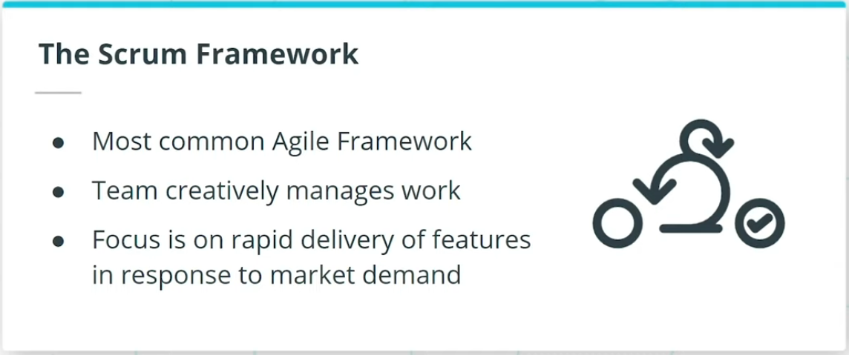

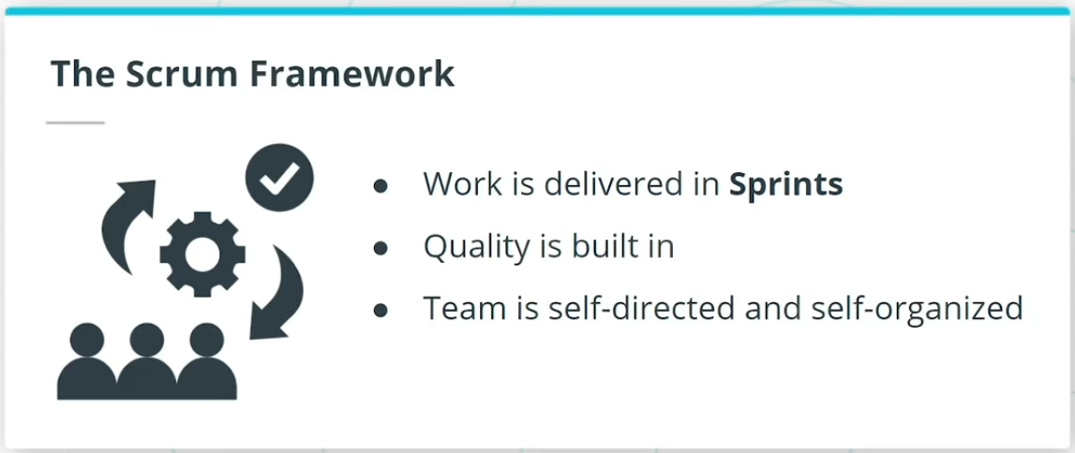

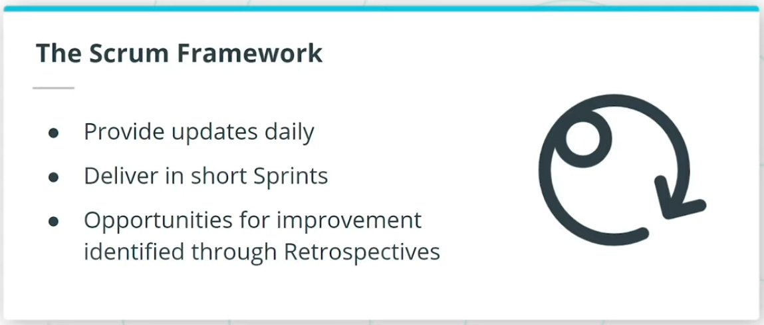

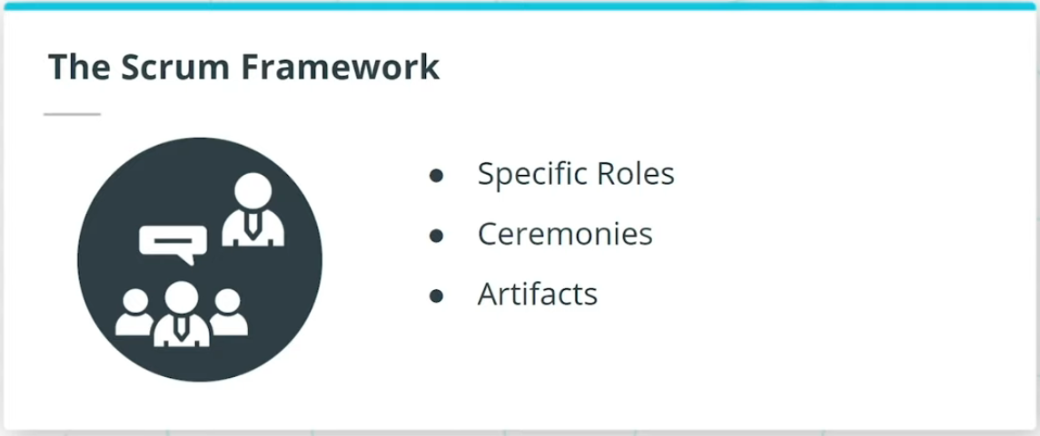

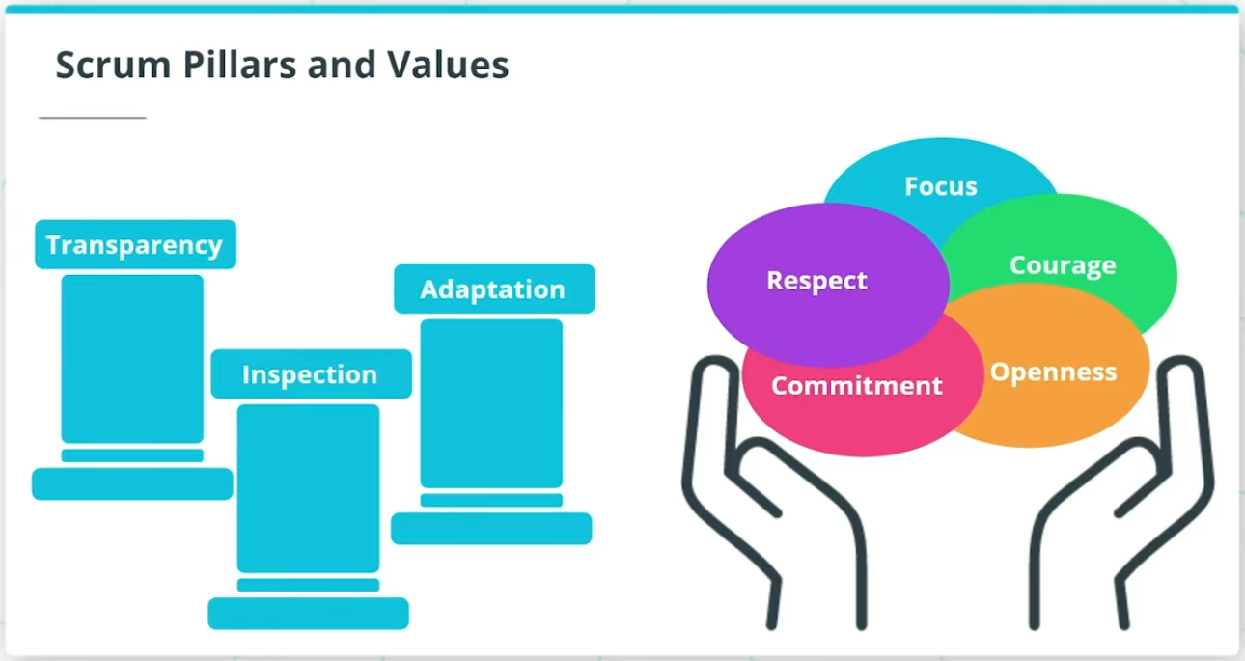

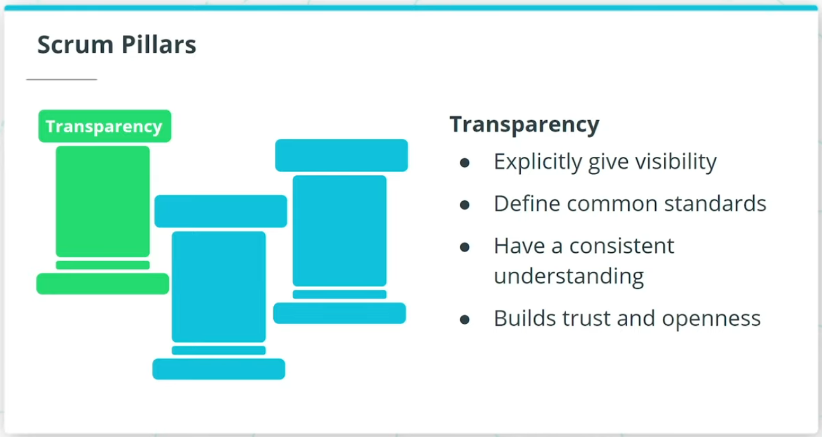

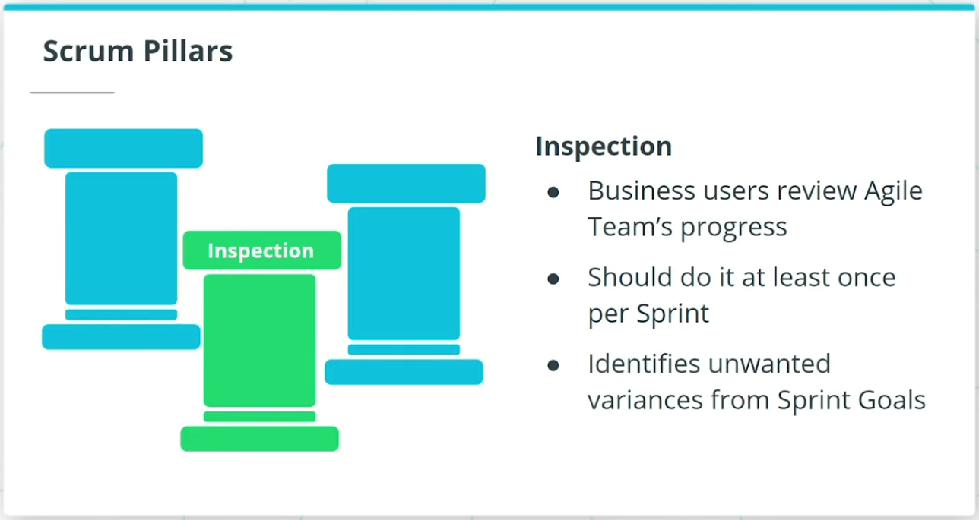

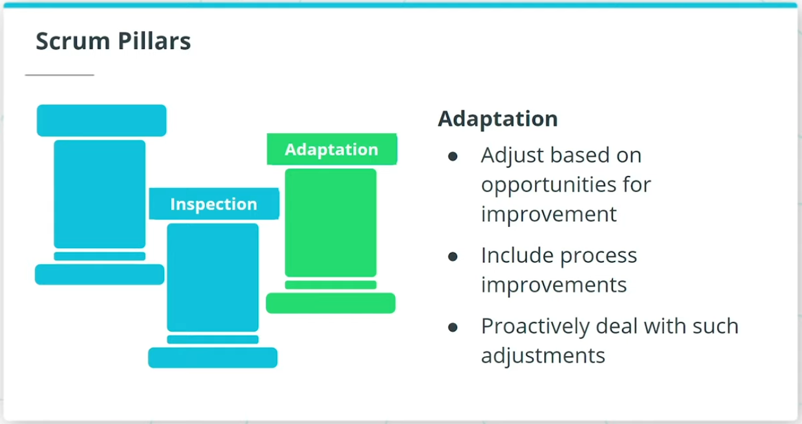

### **Scrum Framework**

Scrum is by far the most common Agile Framework.

* The features are delivered in iterations known as Sprints.
* The Team conducts Daily Stand-Ups in which they provide updates to each other.
* Retrospectives are conducted to identify opportunities for improvement at the end of each Sprint.
* Specific roles, as well as certain Ceremonies, are recommended in the Scrum Framework.

### **Scrum Pillars**

* **Transparency** - Transparency builds trust and openness both within the Agile Team, as well as with those stakeholders outside the Agile Team.
* **Inspection** - Inspection involves the business users reviewing the Agile Team’s progress towards the defined goals.
* **Adaptation** - Agile Teams adjust and adapt based on opportunities for improvement that are identified either by the Agile Team themselves or through feedback from others outside the team.

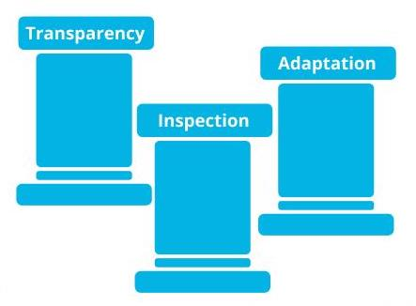

Scrum Pillars: Transparency, Inspection and Adaptation

## Scrum Values

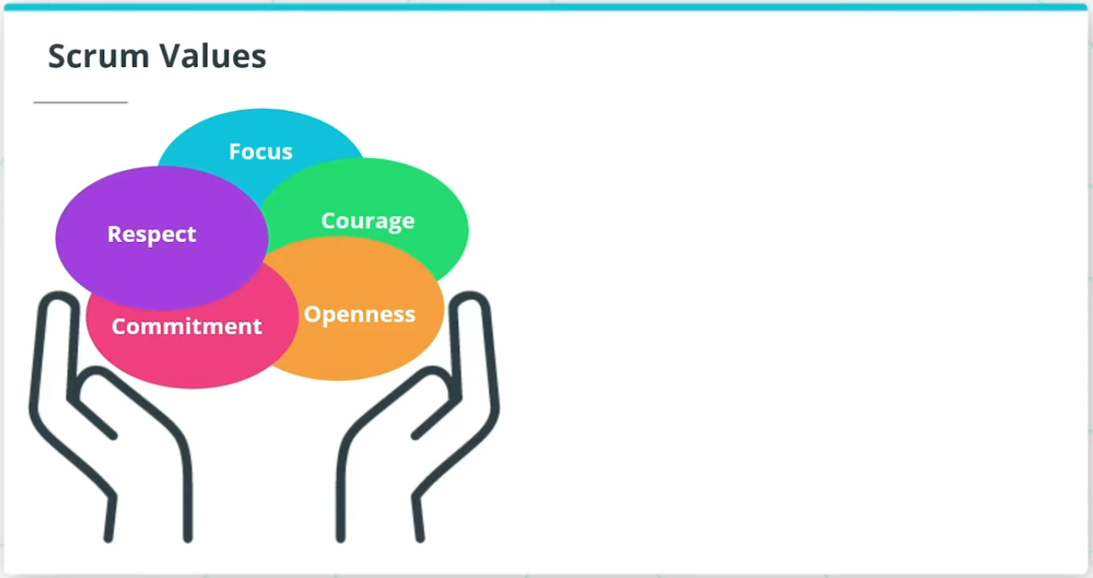

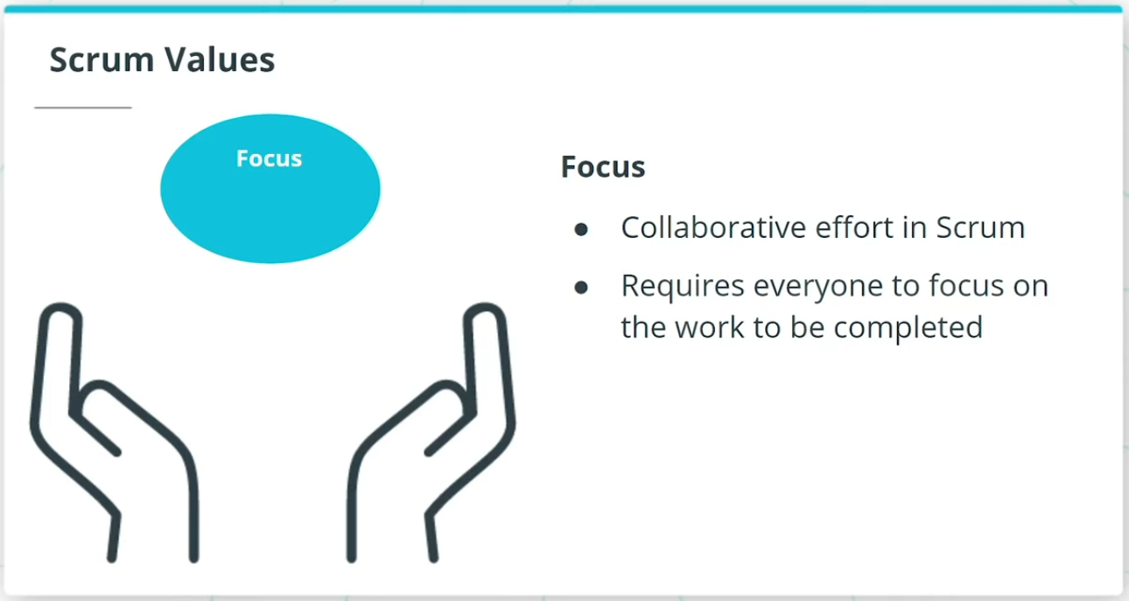

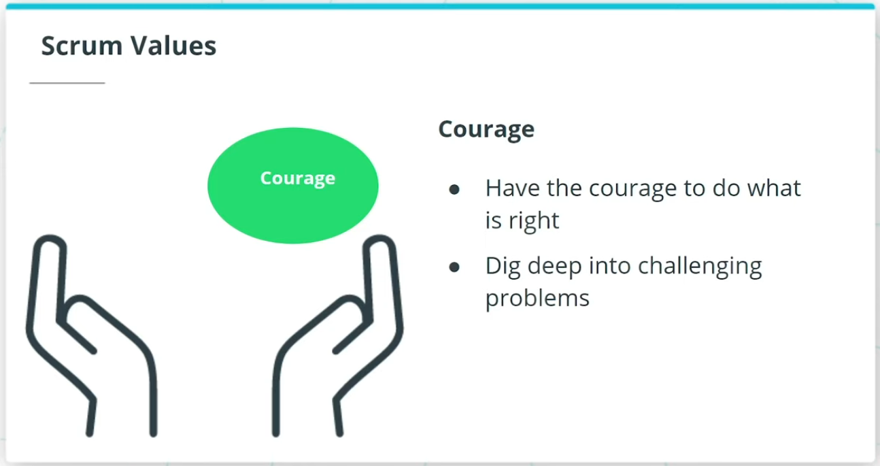

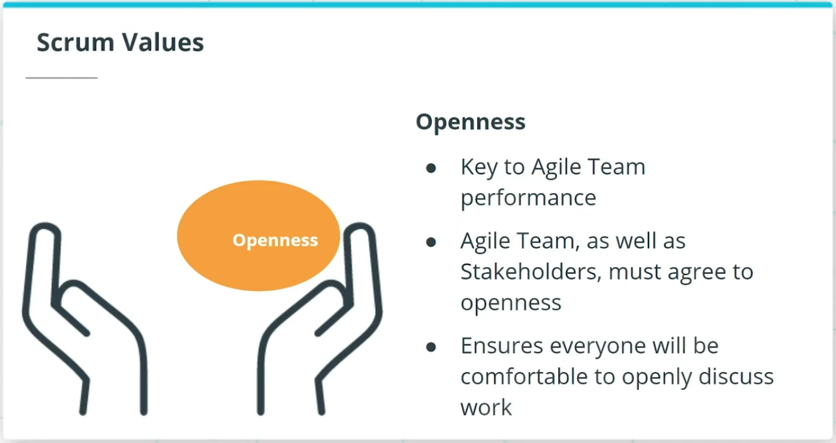

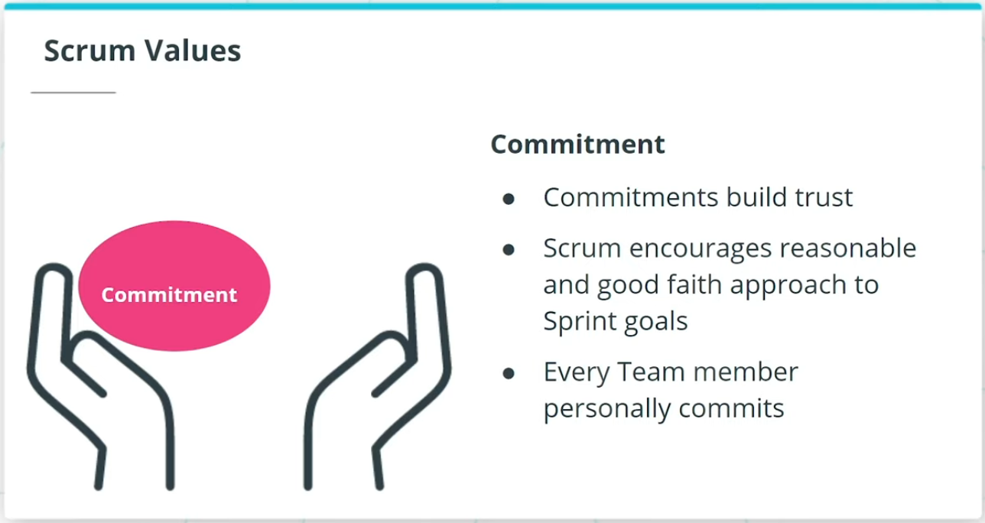

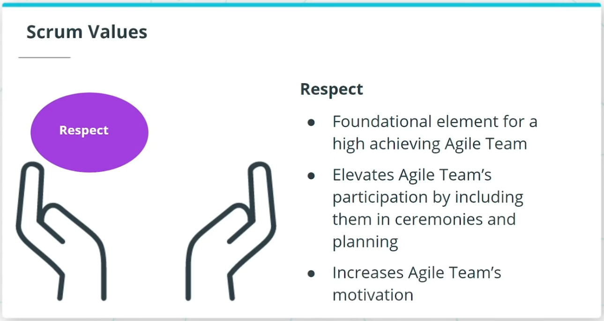

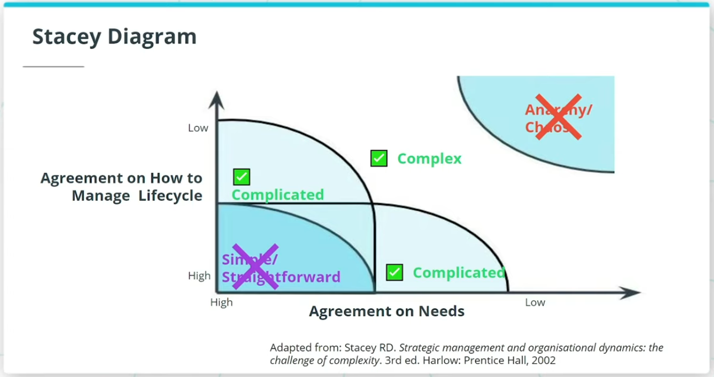

### **5 Scrum Values**

* **Focus** - Everyone in the Team focuses on the work to be completed in order to deliver the Sprint goals.
* **Courage** - Members of the Team need to have the courage to do what is right to ensure the Sprint goals are met.
* **Openness** - The Team and its stakeholders agree to a culture of openness.
* **Commitment** - Commitments build trust within the Agile Team members, as well as with the business users and leaders.
* **Respect** - Respect is a key in Scrum for a high-achieving Agile Team.

### **When Scrum Does Not Make Sense**

As shown in the Stacey diagram, an Agile Framework like Scrum works best with complex and complicated projects and products. There may not be much value in utilizing Agile principles

* when there is a near certainty in both the requirements and process upfront.
* when there is chaos. Scrum cannot bring value to an environment where there is no vision or clear roadmap.
* when the project is simple and predictable and the need for iterative learning and adapting is of no value.

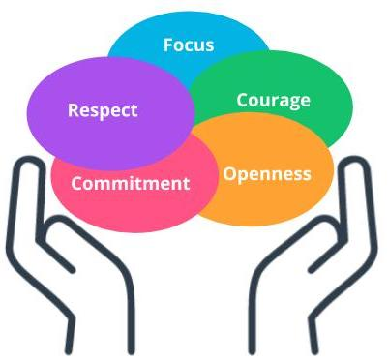

Scrum Values

### **New Terms**

* **Scrum**: Scrum is one of the most popular Agile frameworks for developing complex products, with an emphasis on value delivery
* **Scrum Pillars**: Transparency, Inspection, Adaptation
* **Scrum Values**: Focus, Courage, Openness, Commitment, Respect
* **Sprint**: A Sprint in Scrum is a repeatable fixed time-box iteration during which a minimum shippable product is delivered

### **Additional Resources**

* [**Scrum Guide(opens in a new tab)**](https://www.scrum.org/resources/scrum-guide?gclid=Cj0KCQjwhIP6BRCMARIsALu9LfnAyjv8_sgGwYw7igmvP6xYi0kb9-lwQv0M6FWeO5I0O2ZNSj9Uv_QaAqOKEALw_wcB): The Scrum Guide provides complete details on the Scrum Framework.
* Kenneth Rubin. ***Essential Scrum: A Practical Guide to the Most Popular Agile Process: A Practical Guide To The Most Popular Agile Process***. Pearson, 2013.  
  This book is a comprehensive guide to the Scrum framework.

# Scrum Ceremonies and Roles

## Scrum Ceremonies, Project Vision, Daily Stand Up, and Sprint Planning

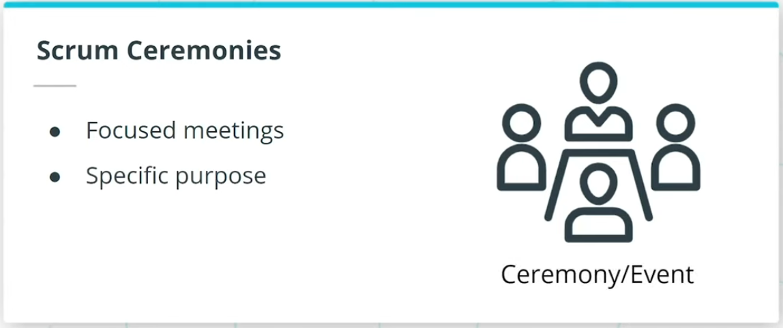

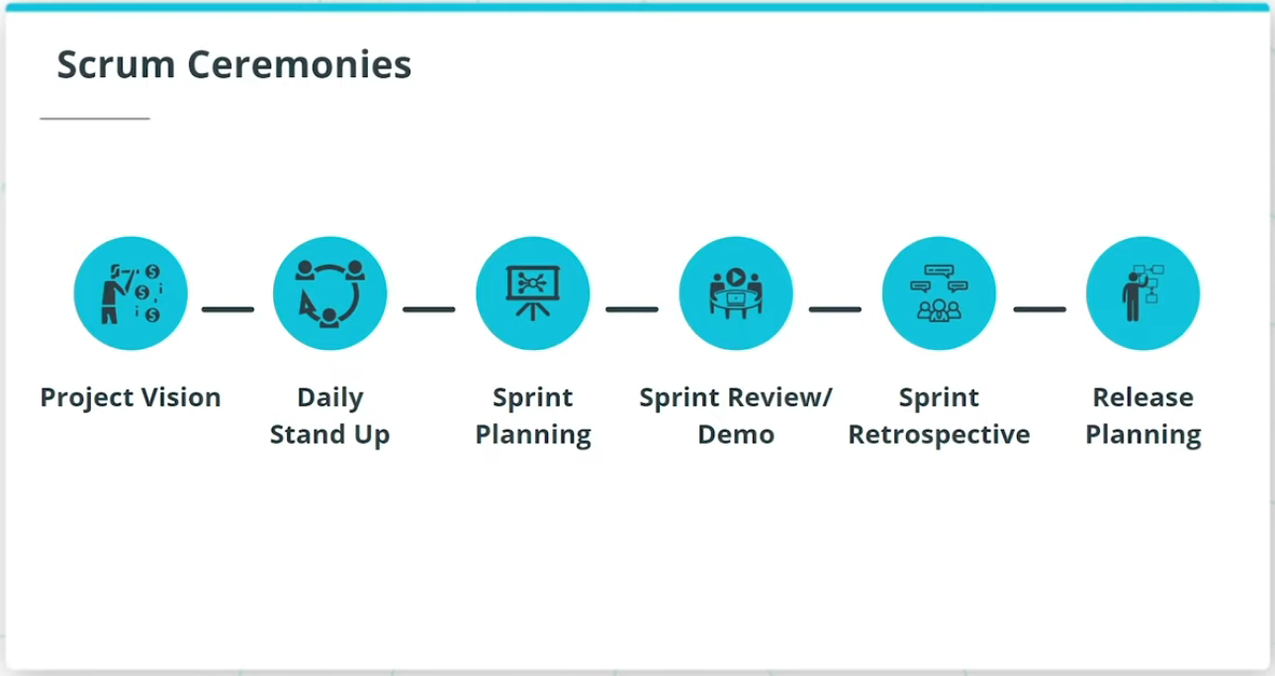

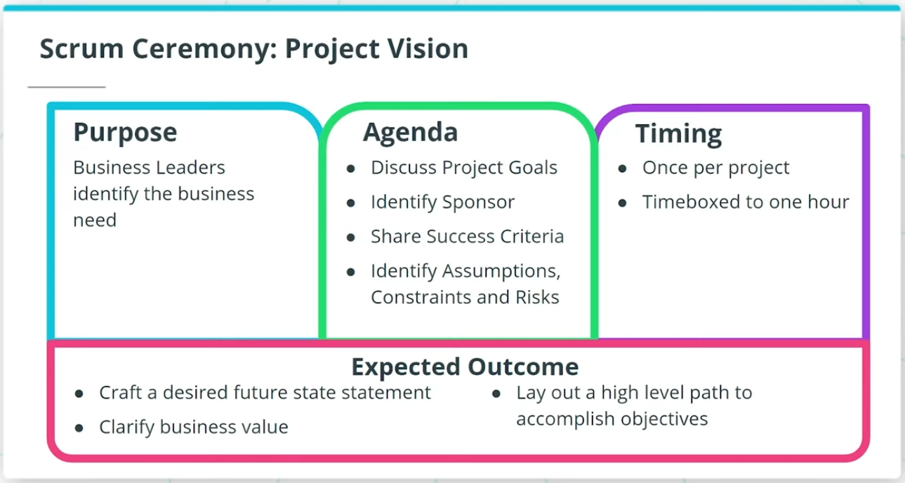

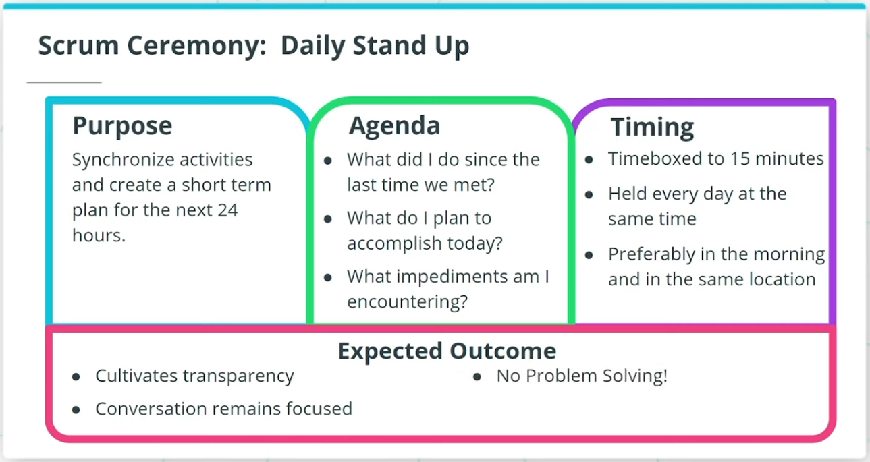

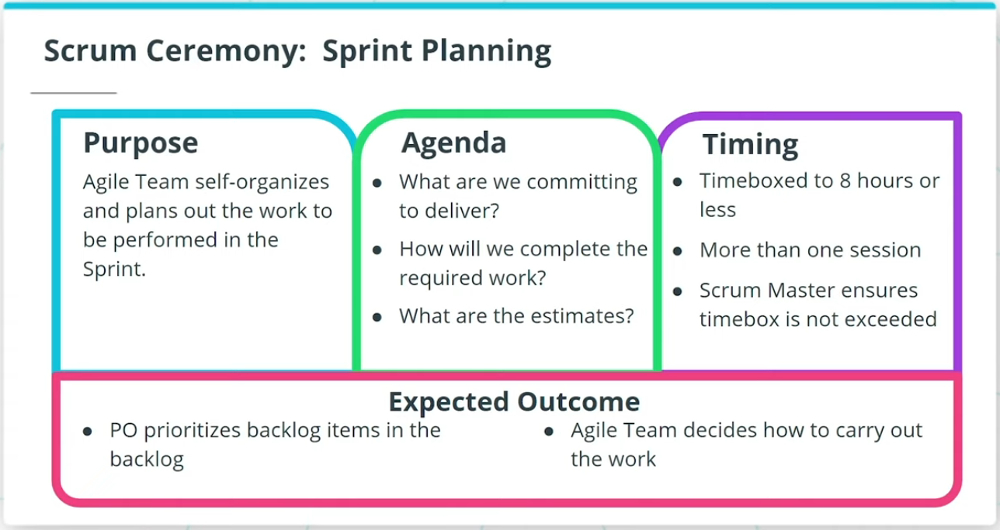

### **Scrum Ceremonies**

Scrum Ceremonies are focused meetings with a specific purpose. The recommended Scrum Ceremonies are:

* Project Vision
* Daily Stand Up
* Sprint Planning
* Sprint Review/Demo
* Sprint Retrospective
* Release Planning

We will discuss each of these Ceremonies.

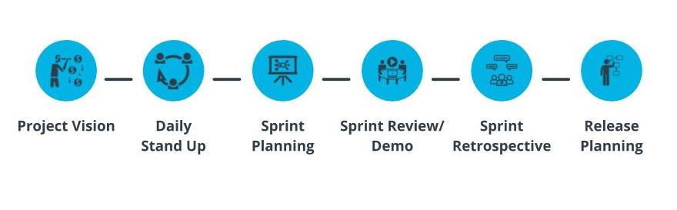

Scrum Ceremonies

### **Project Vision, Daily Stand Up, and Sprint Planning**

### **Project Vision**

* Project Vision Ceremony is where the business leaders identify the business need the project’s product deliverable is intended to achieve.
* Agenda - Discuss the project goals, identify the sponsor, and outline the project vision, success criteria, assumptions, constraints, and risks.
* Project Vision occurs ***once per project*** and is scheduled before the project launch.
* Scrum recommends this ceremony be time-boxed to 1 hour.
* Outcome - Business leaders create a desired future state statement.

### **Daily Stand Up or Scrum**

* The Daily Stand Up is used to synchronize activities and create a short-term plan for the next 24 hours.
* It is time-boxed to 15 minutes and is ***held every day***, throughout the whole scrum ceremonies, ideally at the same time daily.
* Three questions are addressed by each Team member briefly:
  1. What did I do since the last time we met?
  2. What do I plan to accomplish today?
  3. What impediments am I encountering?
* This is a very valuable Ceremony in which all Team members get an opportunity to report issues they are facing; cultivates transparency across the product development journey.

### **Sprint Planning**

* The Team self-organizes and plans out the work to be performed in the Sprint.
* The work is prioritized by the Product Owner.
* Time-boxed to not more than eight hours for a one-month Sprint.
* Agile Team works with the PO and Scrum Master to address the following three questions:
  1. What are we committing to deliver in the upcoming Sprint?
  2. How will we complete the work required to achieve this commitment?
  3. What are the respective estimates for each user story and associated tasks?
* The Agile Team takes the prioritized backlog items and collaborates on how to carry out the work.

Notes: the Daily Stand Up or Scrum is held daily, including the time between Sprint Planning and Sprint Review.

## Sprint Review/Demo, Retrospective, and Release Planning

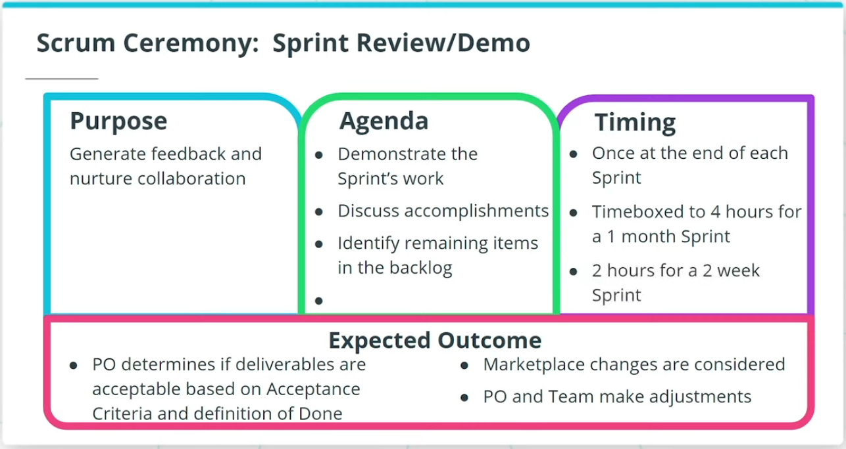

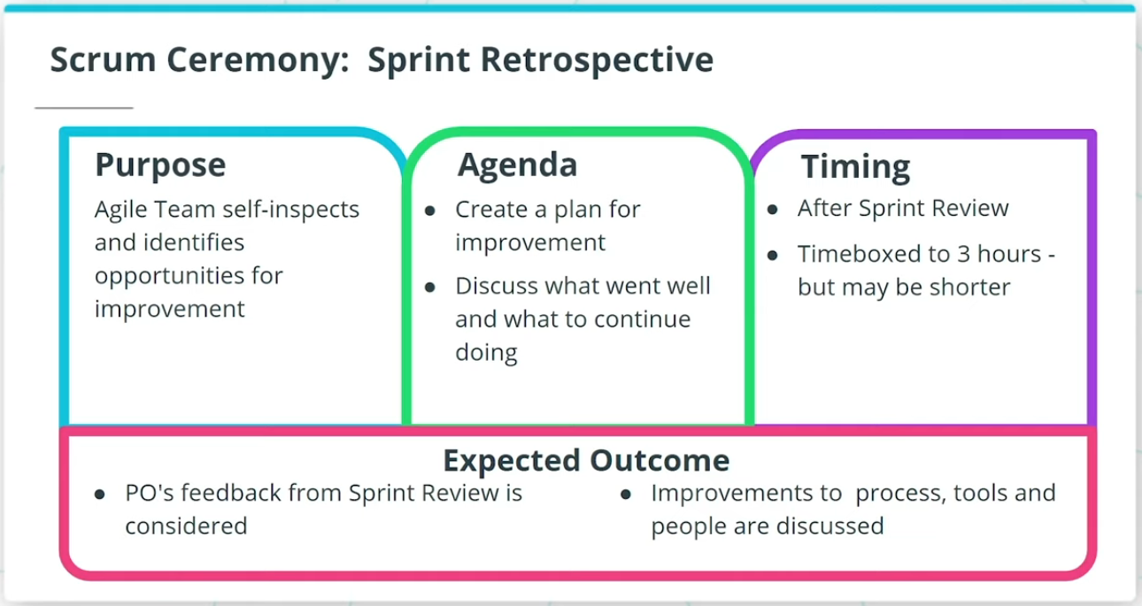

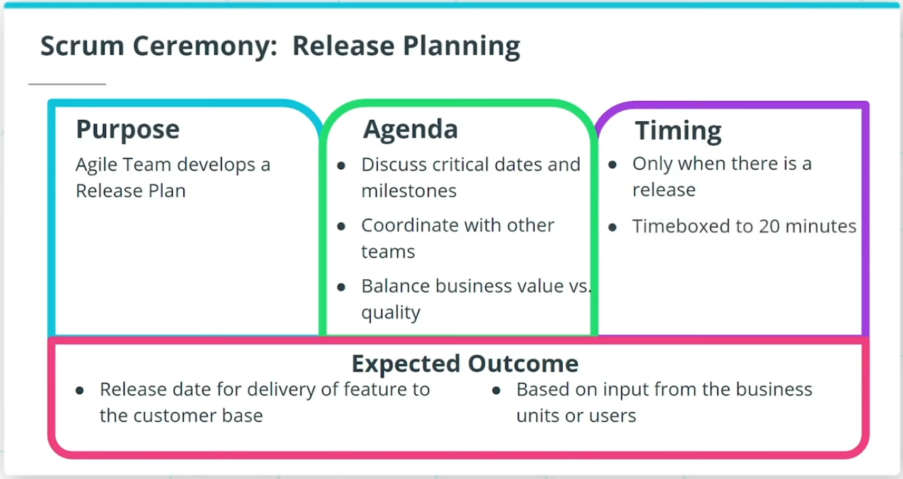

### **Sprint Review/Demo, Retrospective, and Release Planning**

### **Sprint Review/Demo**

* The purpose is to generate feedback and nurture collaboration.
* The Team demonstrates the Sprint’s incremental work to the PO and other business representatives.
* The Team and PO transparently discuss accomplishments, as well as opportunities for improvement.
* The PO determines if the Sprint deliverables are acceptable based on the Acceptance Criteria and Definition of Done.
* Occurs once at the end of each Sprint with a time-box of 4 hours for a one-month Sprint.

### **Sprint Retrospective**

* The Team self-inspects its performance during the Sprint and identifies practical opportunities for improvement for subsequent Sprints.
* Retrospectives are held after the Sprint Review; time-boxed to 3 hours for a one-month Sprint.
* The Team also discusses what went well, as well as what to continue to doing that is working very well for the Agile Team in terms of delivering value.

### **Release Planning**

* The Team develops a Release Plan that defines when a collection of functionality will be delivered to the customer base.
* The agenda is to discuss critical dates and milestones, coordinate with dependent departments and systems, and balance business value vs quality.
* Only occurs when there is a Release; time-boxed to 20 minutes.

## Scrum Roles and Artifacts

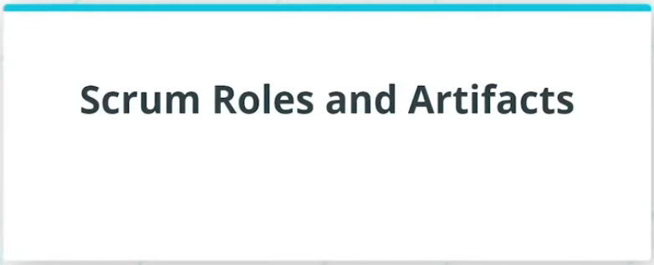

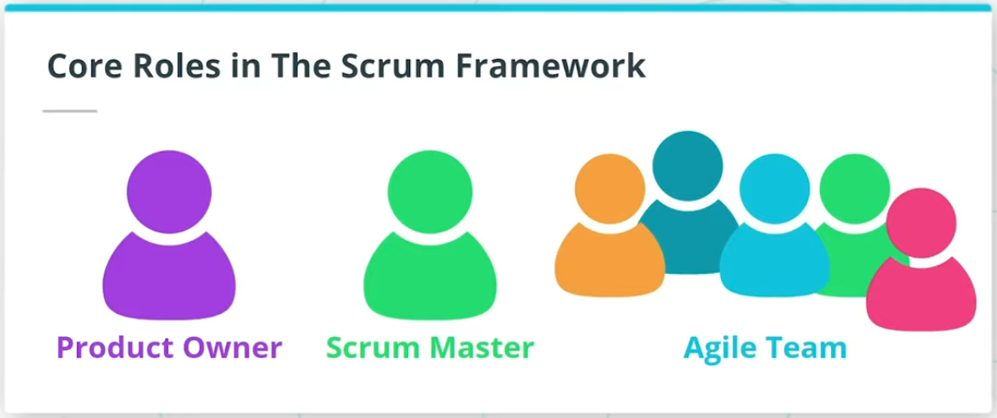

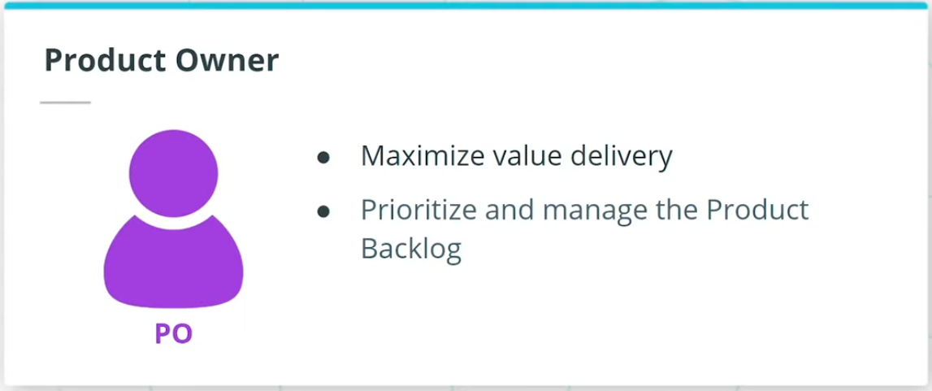

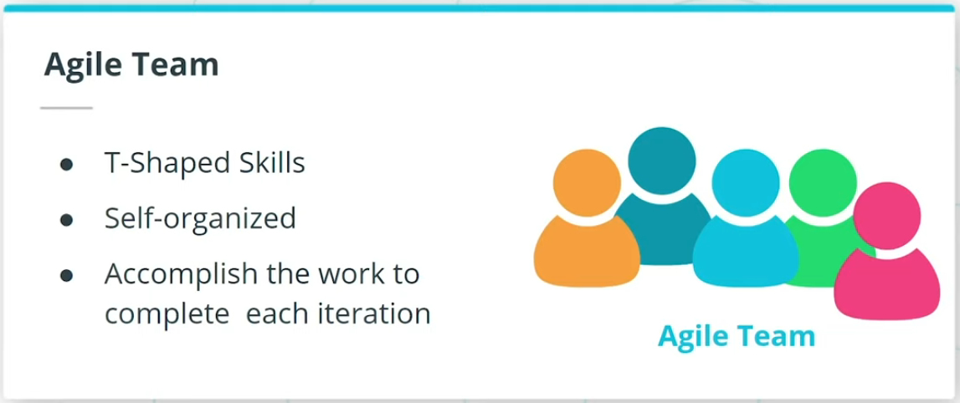

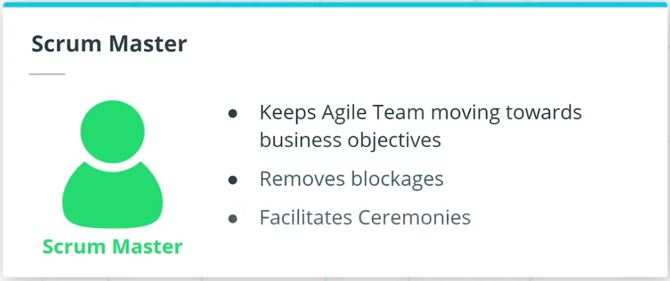

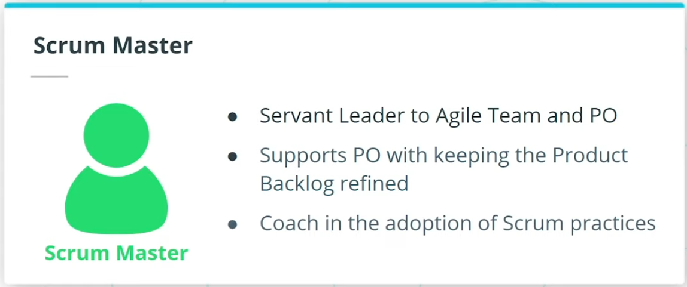

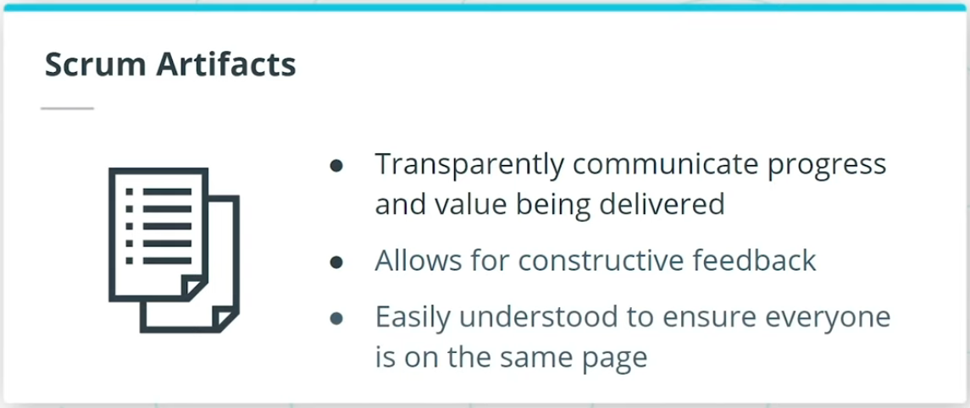

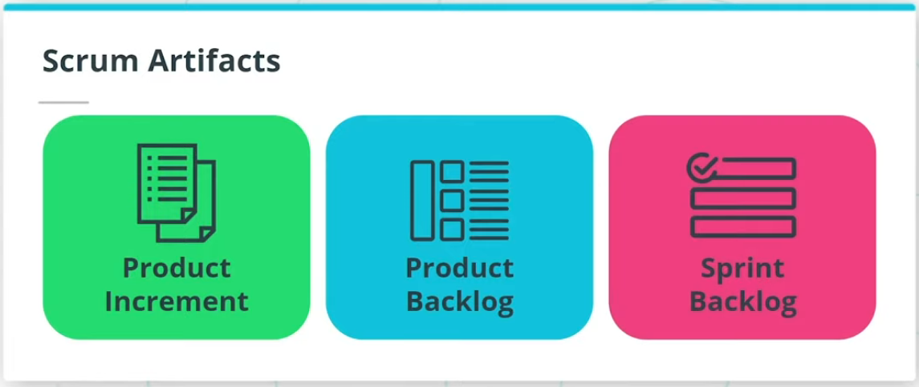

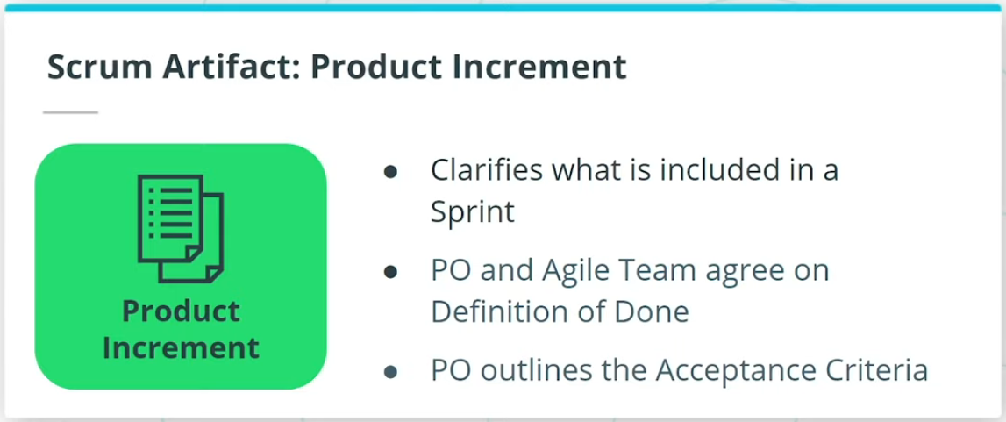

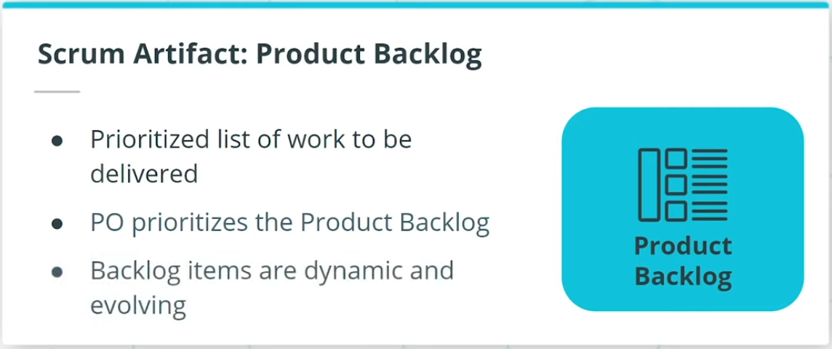

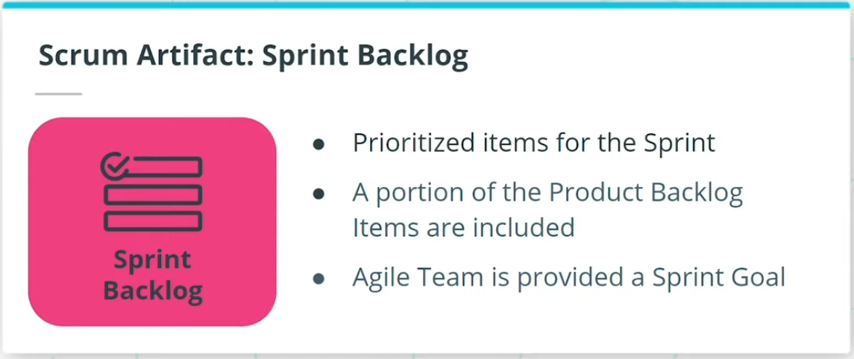

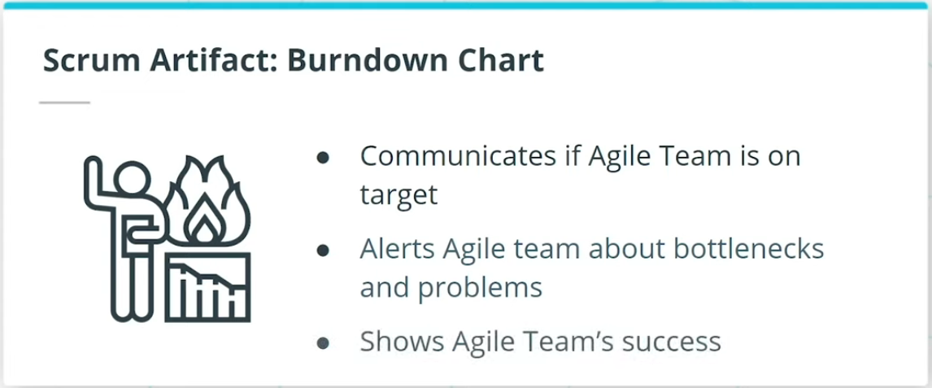

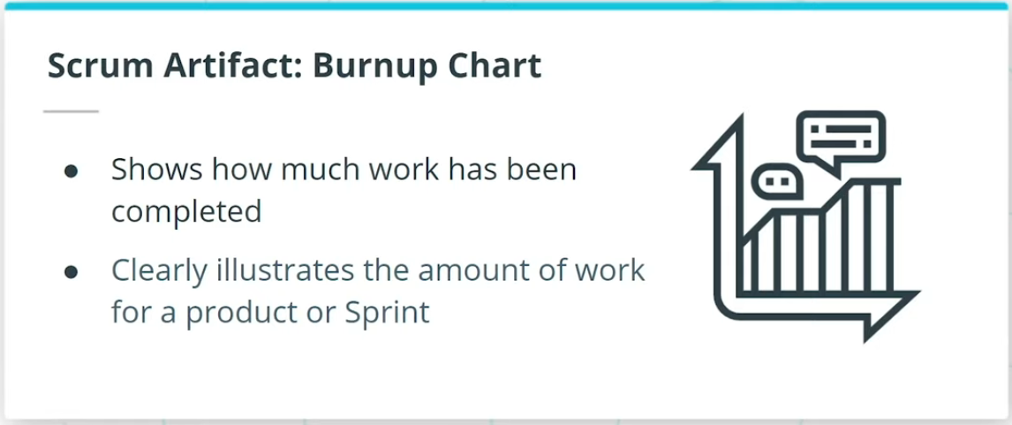

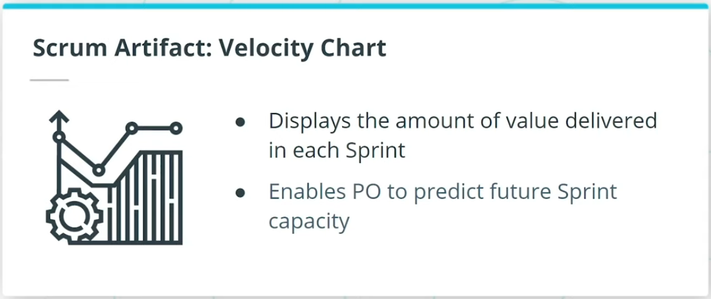

### **Scrum Roles**

Similar to other Agile Frameworks, there are 3 core roles in the Scrum Framework.

* Product Owner, who is the voice of the customer.
* Scrum Master, who is the key facilitator.
* Agile Team, also known as the Scrum Team sometimes.

### **Scrum Artifacts**

* **Product Increment** clarifies what is being delivered in each increment at the end of each Sprint.
* The **Product Backlog** is the prioritized list of work to be delivered by the Team. The Backlog items are dynamic and evolving based on emergent needs of the business and customer demand.
* The **Sprint Backlog** contains the prioritized items that the PO has designated for the Sprint.

There are other useful information radiators that are commonly used by Agile teams to track and share progress. These information radiators include Burndown Charts, Burnup Charts, and Velocity Charts.

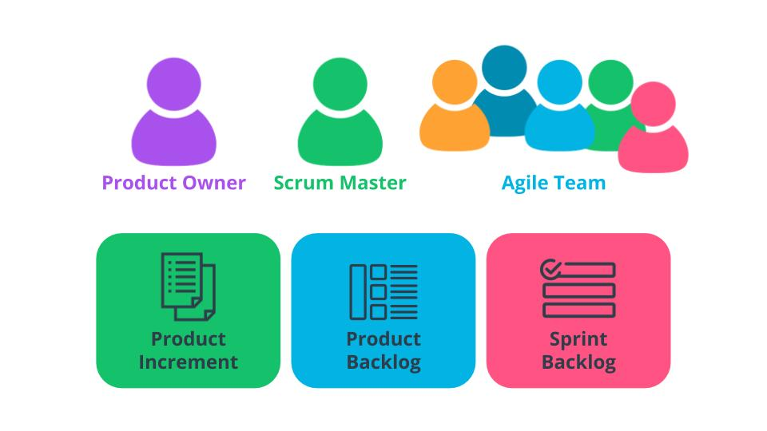

Scrum Role and Artifacts

### **New Terms**

* **Burndown Chart**: A visual representation of work left to do versus time in an iteration
* **Burnup Chart**: A visual representation of work completed versus time in an iteration
* **Ceremonies**: Meetings that are leveraged to ultimately ensure that everyone associated with the project is in-sync
* **Daily Stand Up**: A ceremony to create a short term plan for the next 24 hours
* **Definition of Done**: The agreed-upon deliverables that must be completed before a user story can be completed
* **Product Backlog**: A prioritized list of Features that an Agile team needs to work on to achieve a specific outcome
* **Product Increment**: The collection of backlog items to be completed during an iteration
* **Project Vision Ceremony**: A ceremony is where the business leaders identify the business need the project’s product deliverable is intended to achieve; the agenda is to discuss the project goals
* **Release Planning Ceremony**: A ceremony where the Agile Team develops a Release Plan that defines when a collection of functionality will be delivered to the customer base
* **Sprint Backlog**: The prioritized items that the PO has designated for the Sprint
* **Sprint Planning Ceremony**: A ceremony is where the Agile Team self-organizes and plans out the work that has been prioritized by the Product Owner
* **Sprint Review/Demo**: A ceremony where the Agile Team demonstrates the Sprint’s incremental work to the Product Owner, as well as possibly other business representatives
* **Velocity Chart**: A chart that shows what the team has delivered in each iteration

### **Additional Resources**

* [**Formula for Building a Successful Scrum Experience(opens in a new tab)**](https://www.scrumalliance.org/agile-resources/resources-for-your-agile-life/agile-advanced/july-2016/select-repost-formula-for-building-a-successful): This blog post discusses a few pointers to practically help your Scrum team excel and deliver additional value.
* [**Vodafone New Zealand's Agile Transformation Case Study(opens in a new tab)**](https://www.scrum.org/resources/blog/vodafone-new-zealands-agile-transformation-case-study): Edwin Dando walks through Vodafone New Zealand's successful implementation of the Scrum Framework.
* [**Scrum’s Nature: It Is a Tool; It Is Not About Love or Hate(opens in a new tab)**](https://www.scrum.org/resources/blog/scrums-nature-it-tool-it-not-about-love-or-hate): Stefan Wolpers discusses how the Scrum Framework is a tool and must be used properly to reap the anticipated value.

# Quizzes: Scrum

## Thinking About Scrum

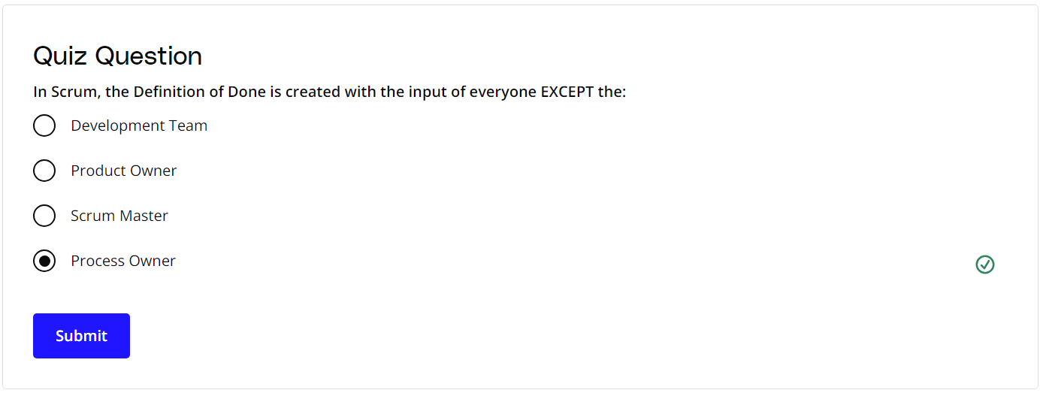

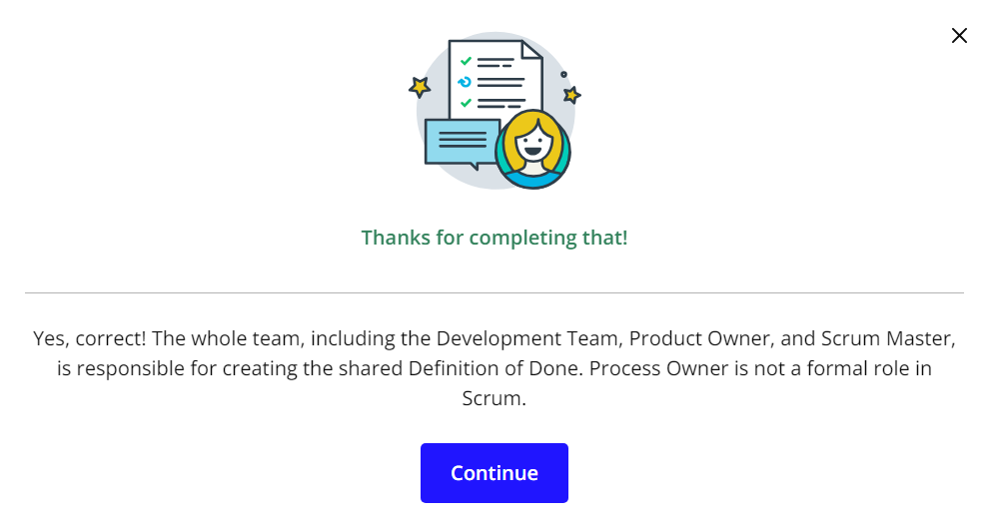

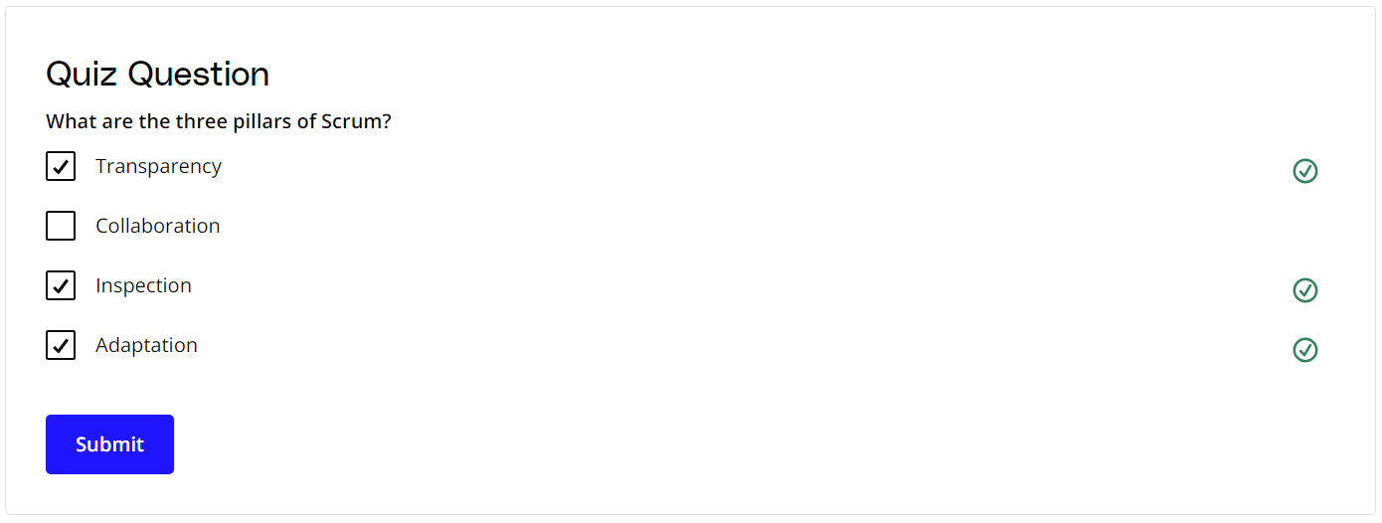

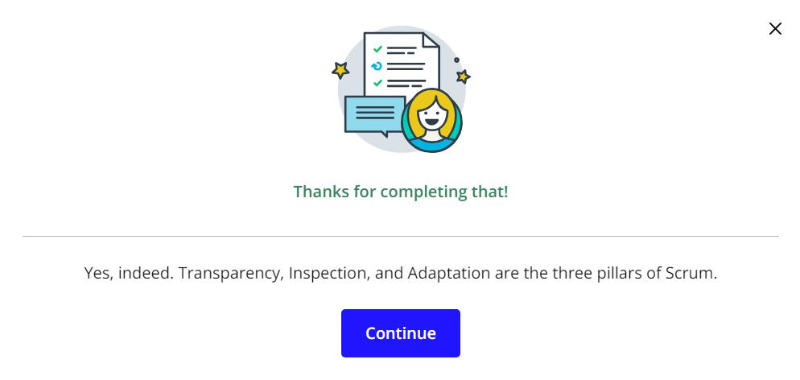

# Exercise: Setting Up Scrum

## Set Up the Scrum Framework At SocialKare.gov

Your leaders at SocialKare.gov have advised you that they wish to proceed with using the Scrum Framework.

Review the [**SocialKare.gov Case Study(opens in a new tab)**](https://video.udacity-data.com/topher/2020/September/5f5f6bc7_agnd-c1-foundations-of-agile-socialkare.gov-case-study/agnd-c1-foundations-of-agile-socialkare.gov-case-study.pdf). Explain how you will set up the Scrum Framework for this project team. Include the following:

* Core roles to be filled
* Ceremonies to be conducted
* Schedule and duration of the ceremonies, as well as their purpose and agenda

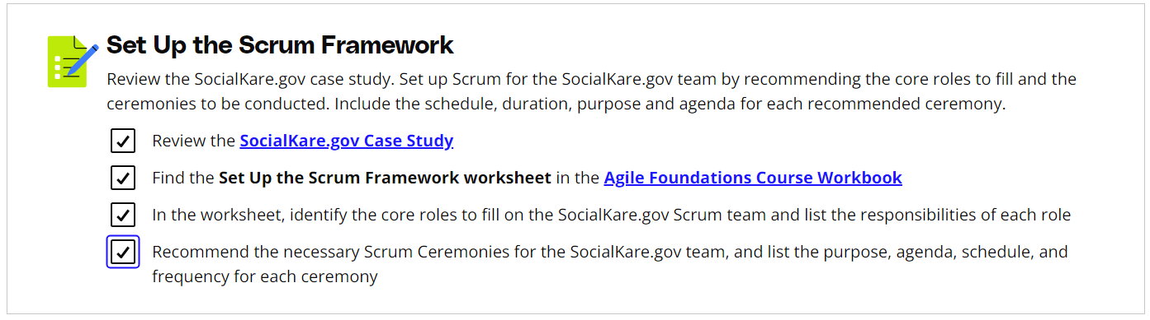

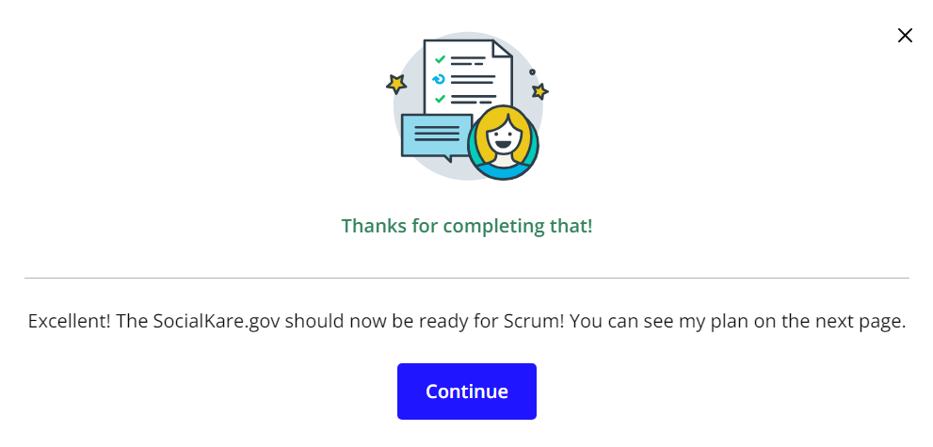

# Solution: Setting Up Scrum

## My Solution

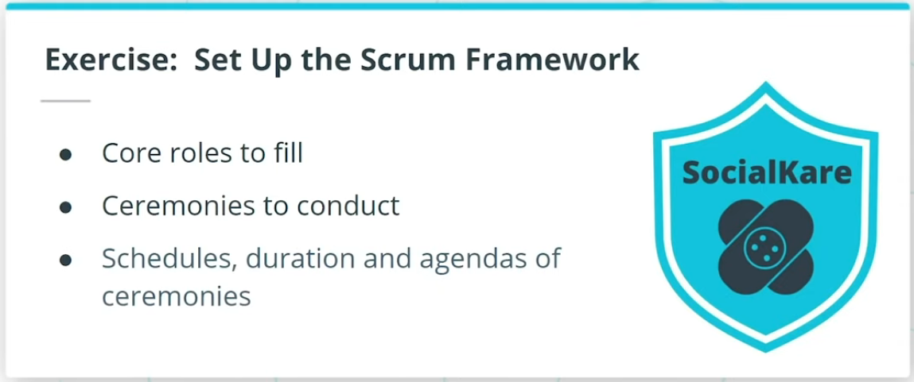

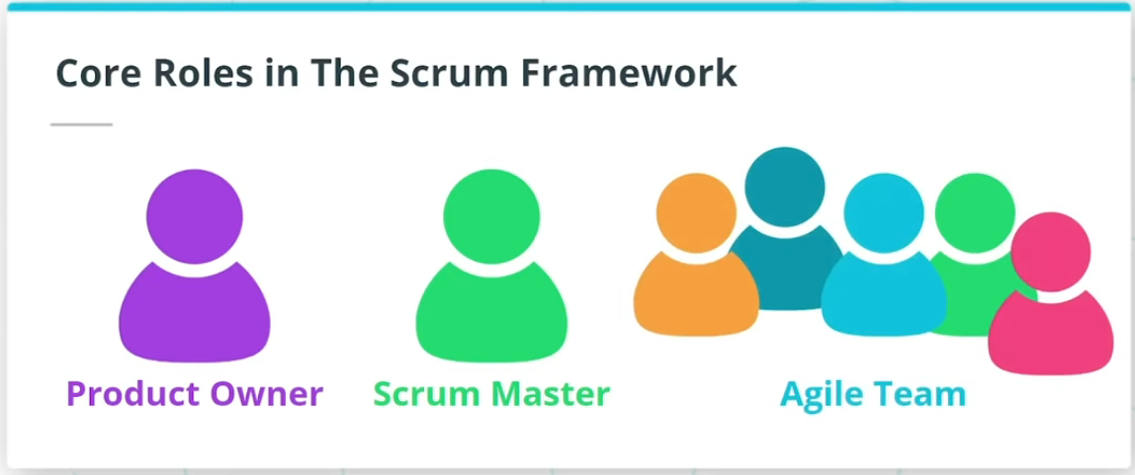

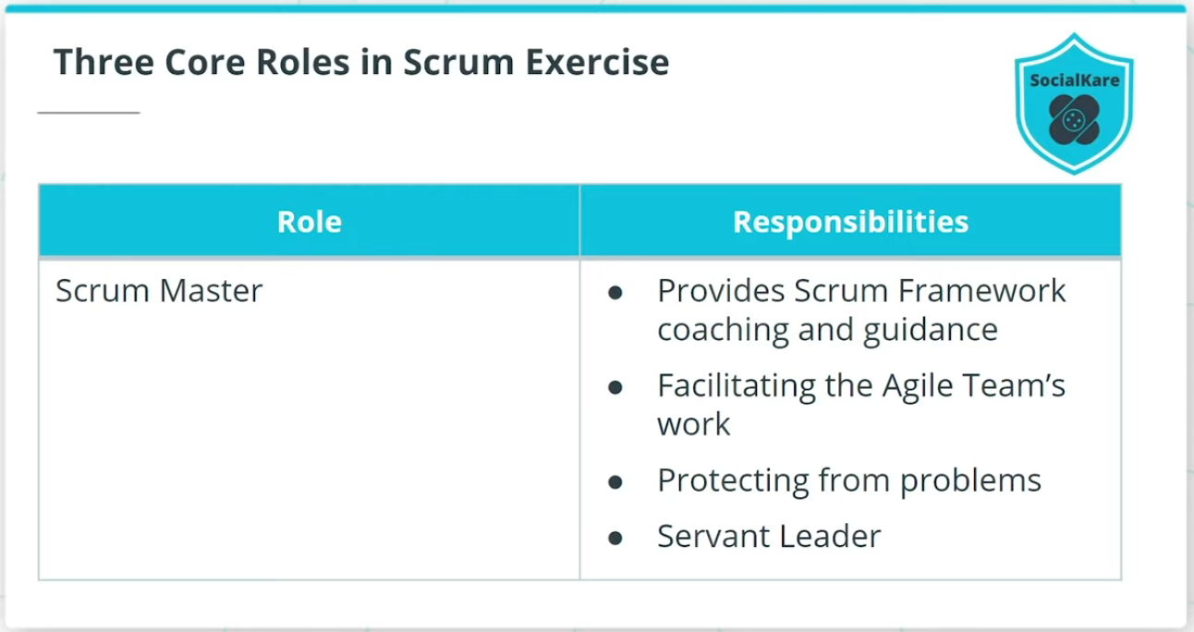

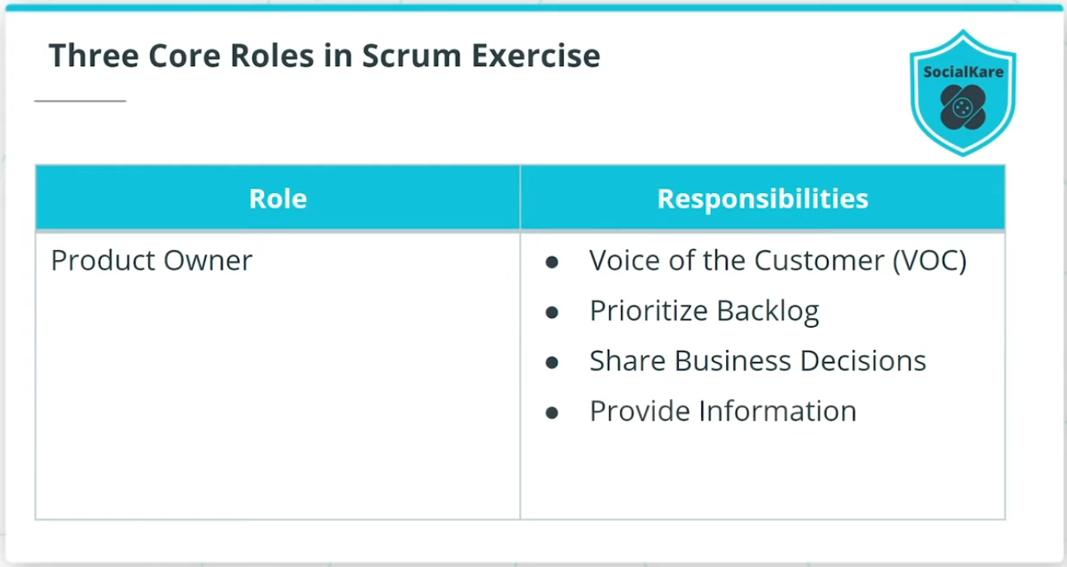

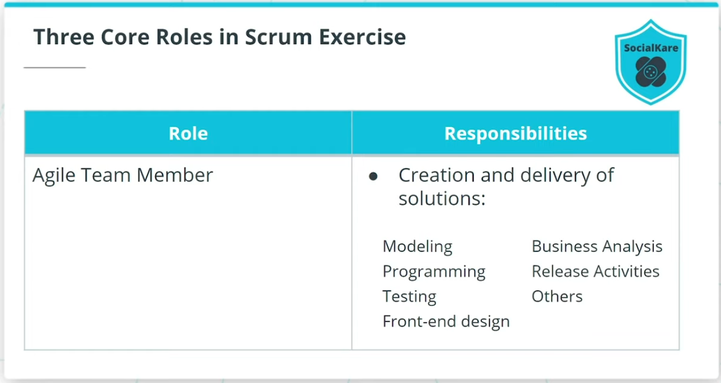

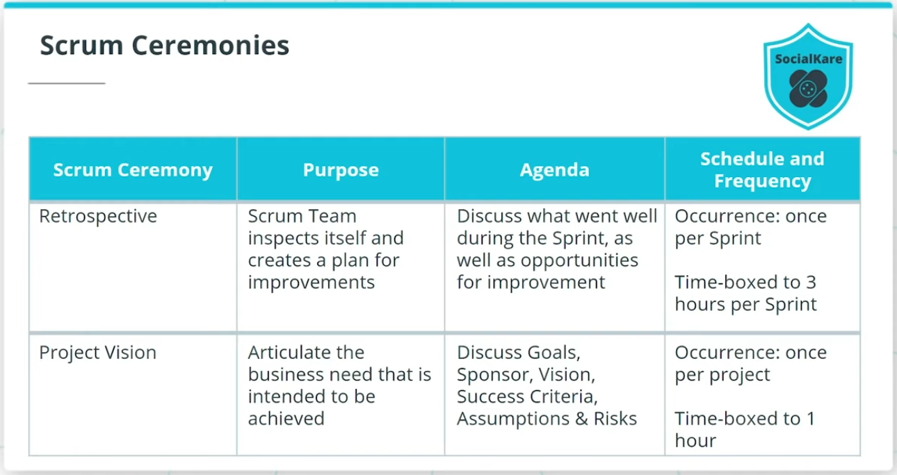

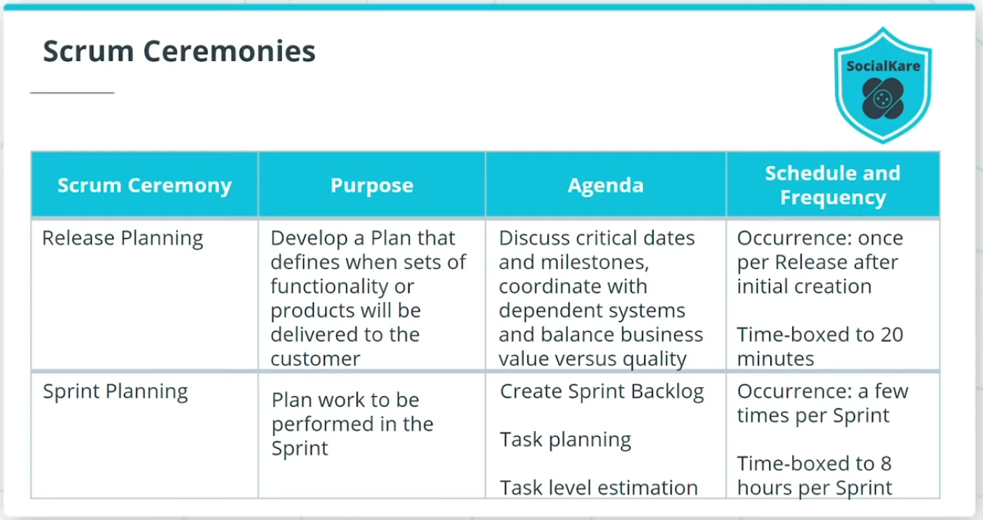

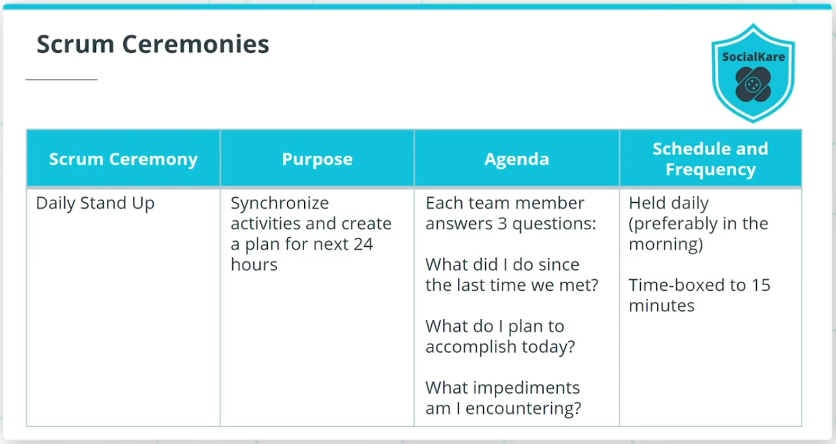

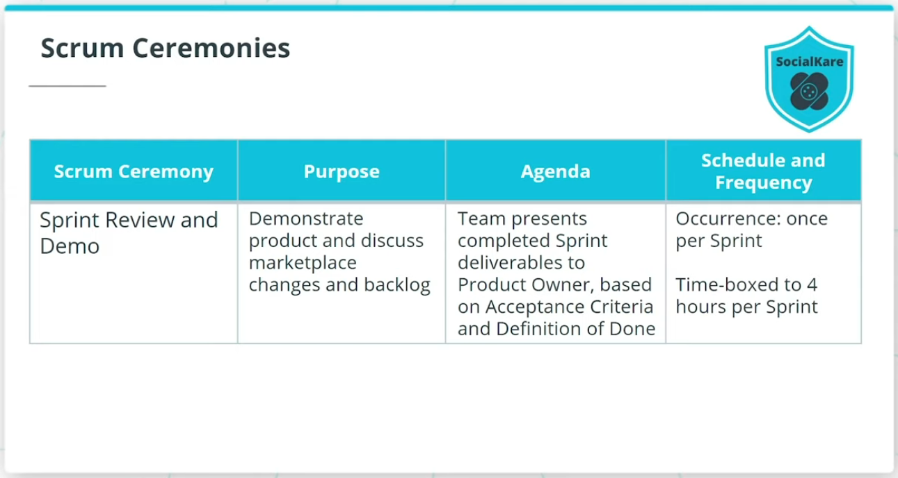

## Set up the Scrum Framework

You were asked to cover the Core roles, as well as Ceremonies and their details.

### **Core Roles in Scrum**

* Scrum Master: Servant Leader to the PO and Team.
* Product Owner: PO represents the SocialKare.gov stakeholders and is known as The Voice of the Customer (VOC).
* Agile Team Member: Responsible for the creation and delivery of product solutions.

### **Scrum Ceremonies**

* Retrospective: An opportunity for the Team to inspect itself and create a plan for improvements; time-boxed to 3 hours once per Sprint.
* Project Vision: Business leaders articulate the business need that is intended to be achieved; time-boxed to 1 hour and occurs once per project.
* Release Planning: A Release Plan is defined as to when various sets of usable functionality or products will be delivered to the customer; time-boxed to 20 minutes per Release.
* Sprint Planning: Work to be performed in the Sprint is planned; can occur a few times per Sprint; time-boxed to a total of 8 hours per Sprint.
* Daily Stand-Ups: The team synchronizes activities and creates a plan for the next 24 hours; Each team member answers 3 questions: What did I do since the last time we met? What do I plan to accomplish today? What impediments am I encountering?; held daily (preferably in the morning); time-boxed to 15 minutes.
* Sprint Review and Demo: Along with Demo, the Team discusses marketplace changes and backlog with PO; the Team presents completed Sprint deliverables to Product Owner; time-boxed to 4 hours once per Sprint.

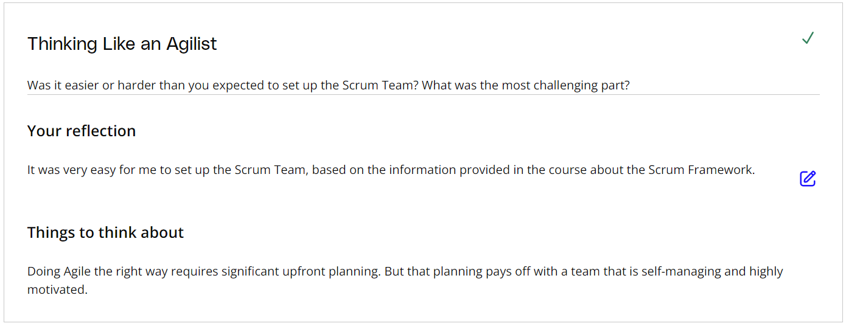

# Kanban

## What is Kanban?

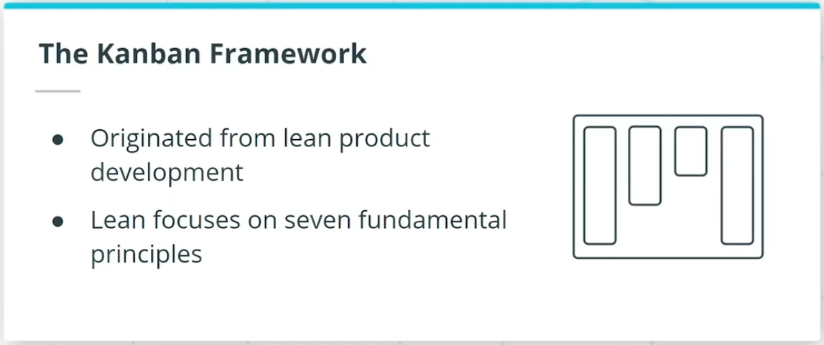

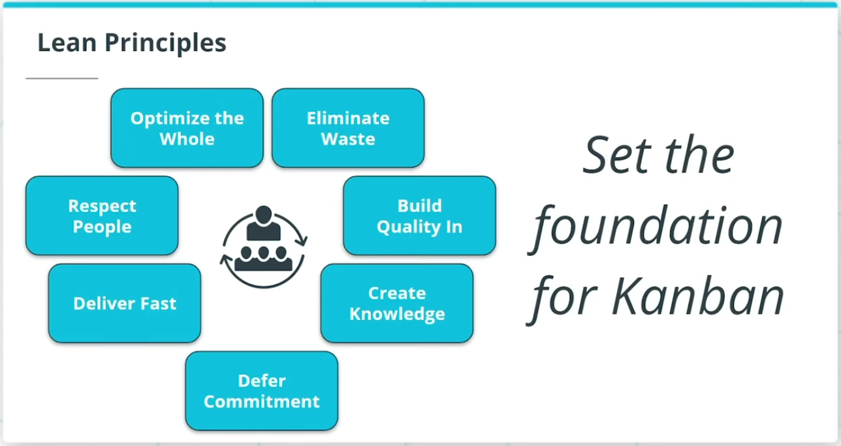

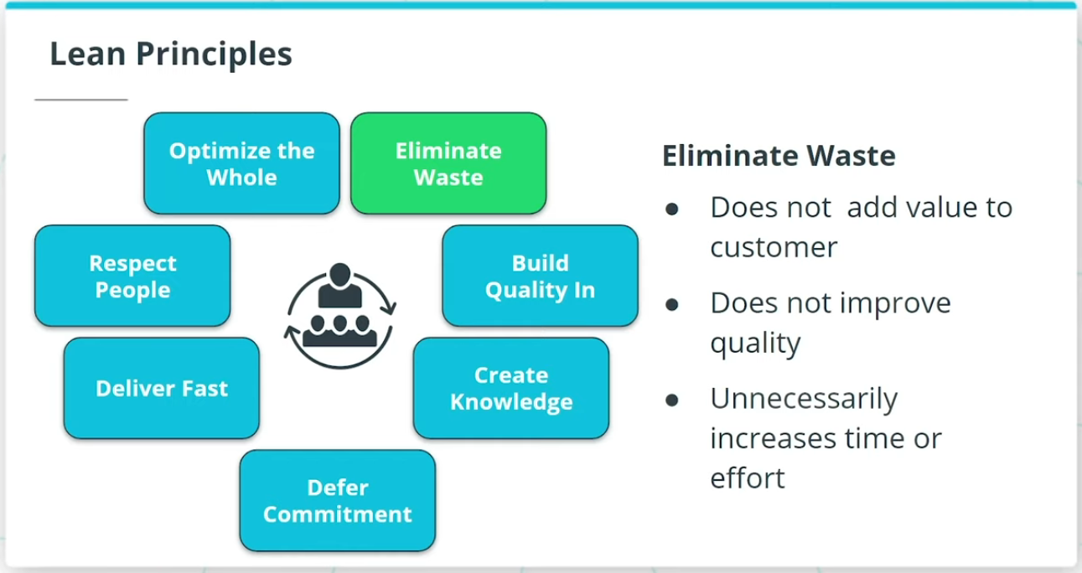

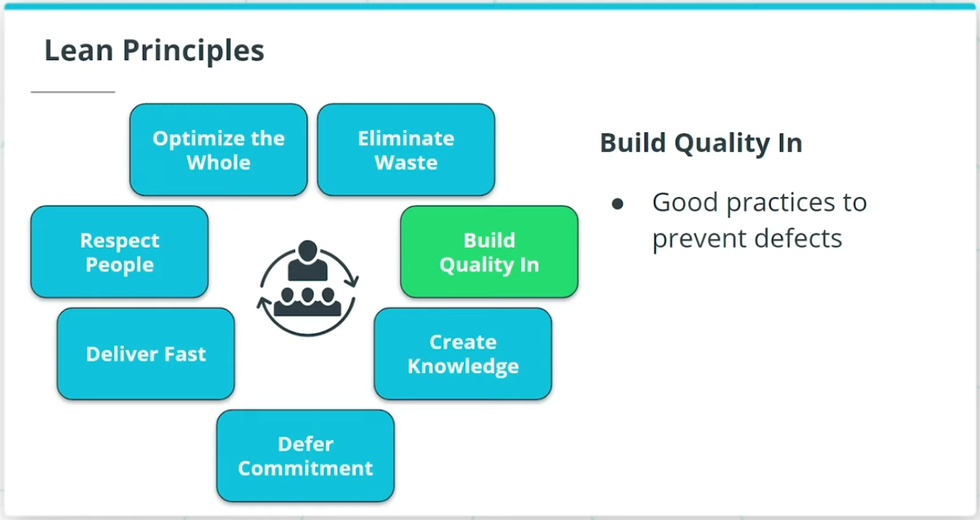

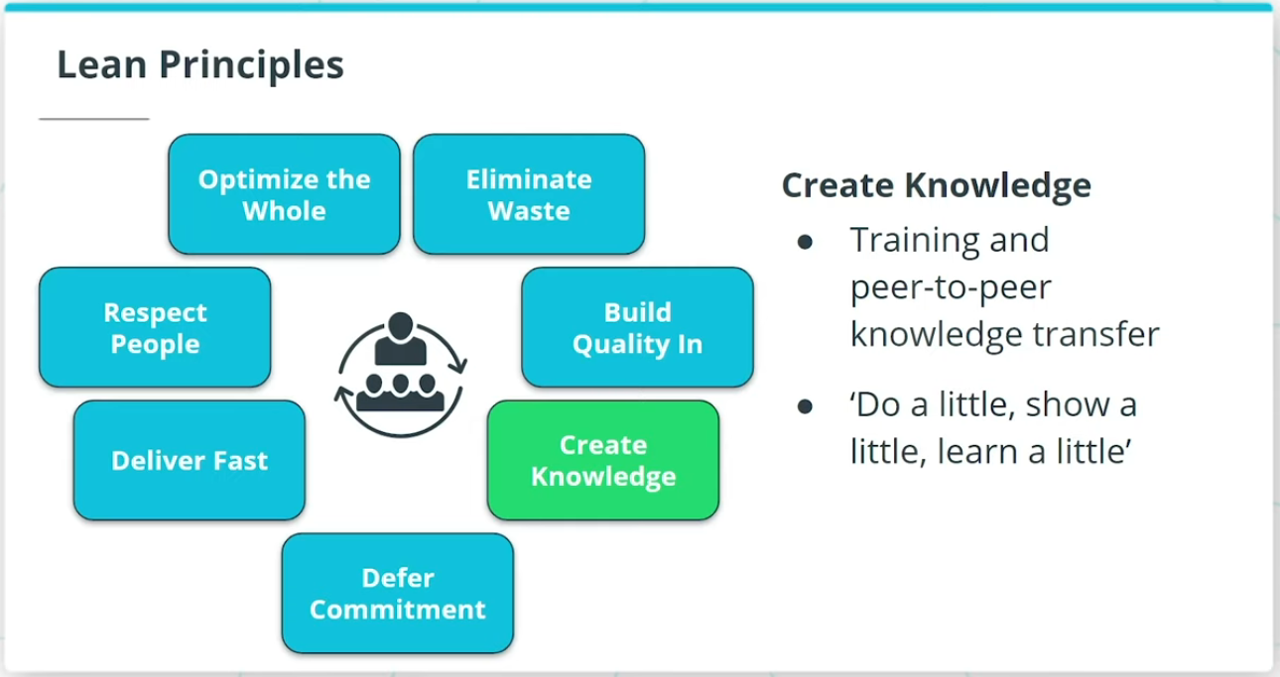

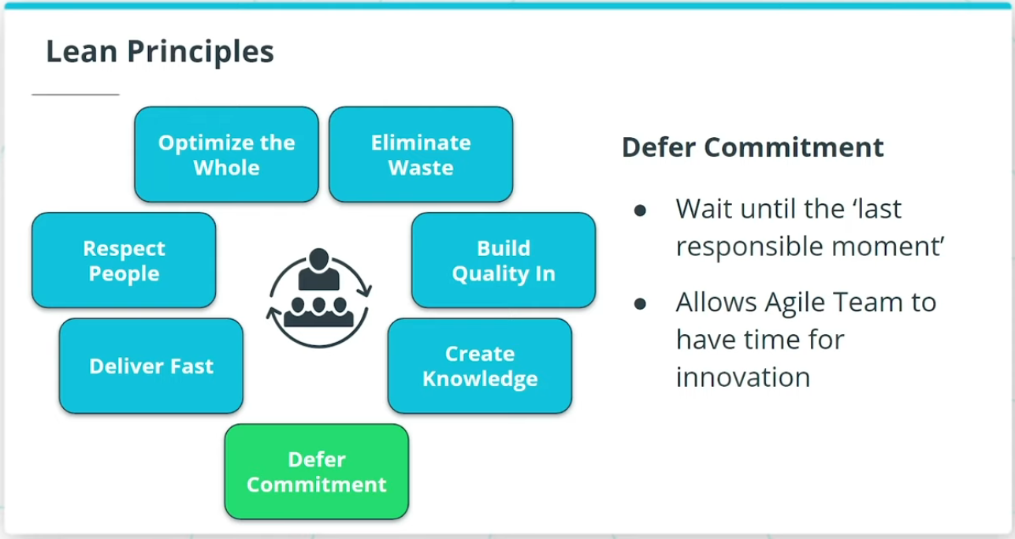

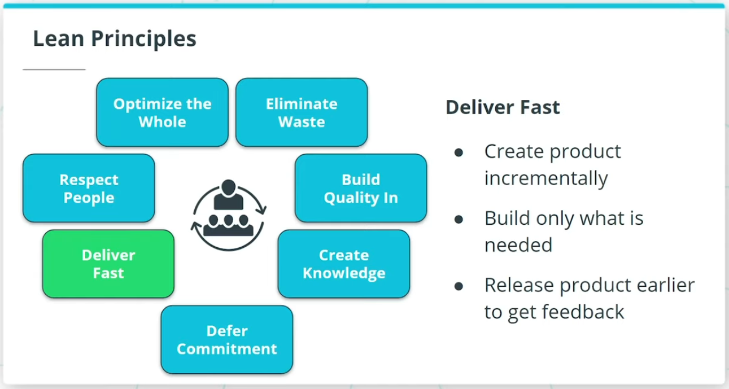

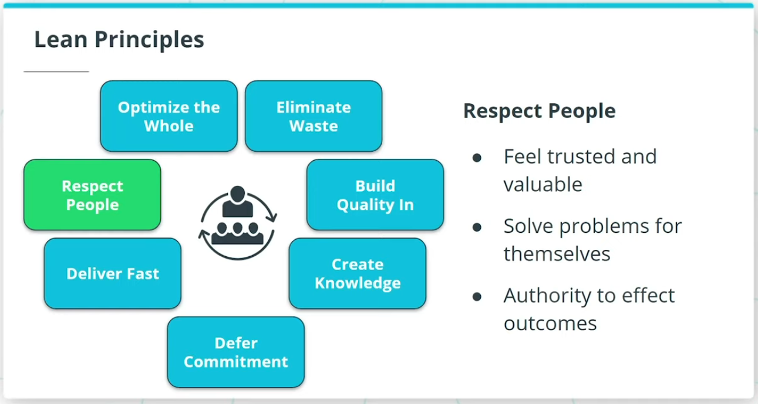

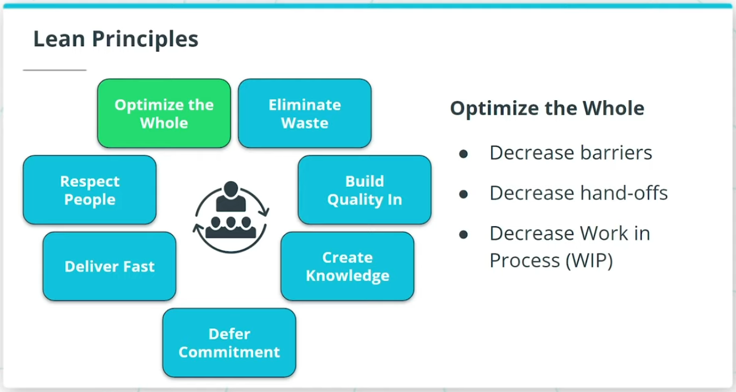

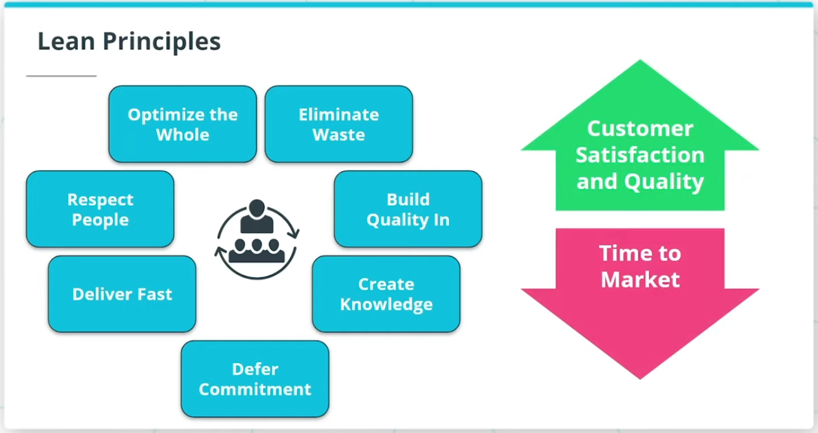

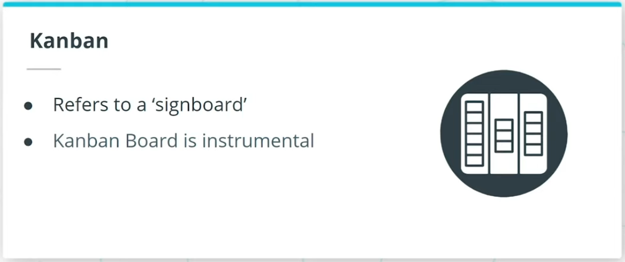

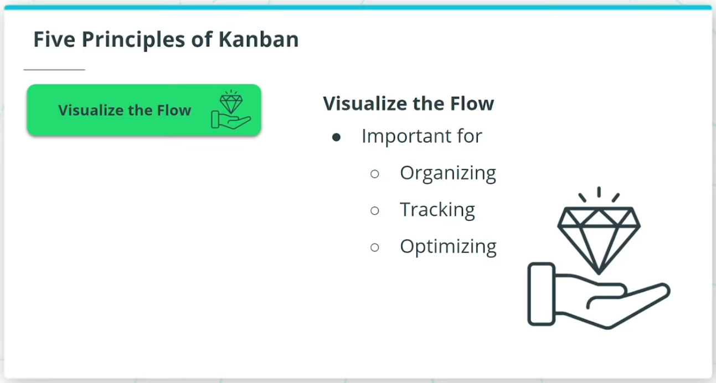

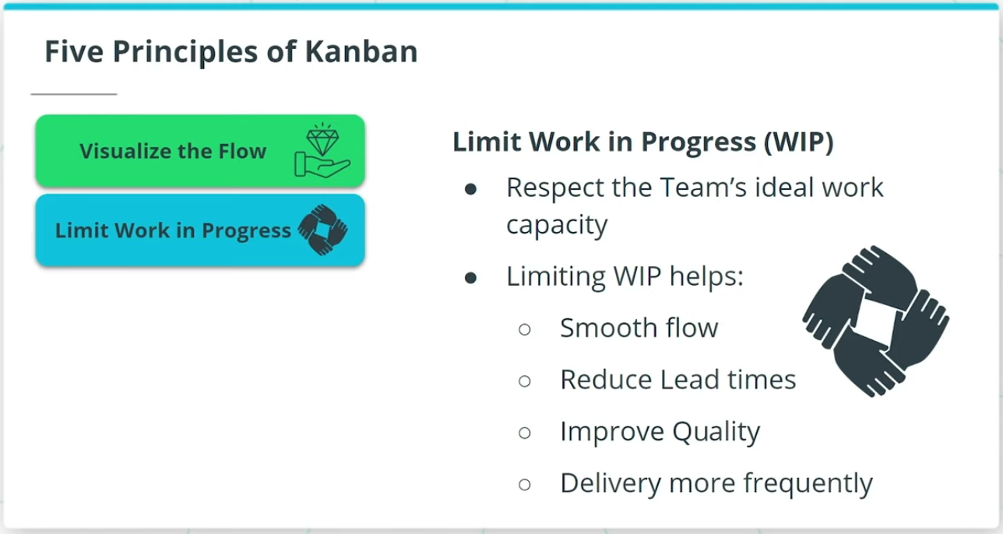

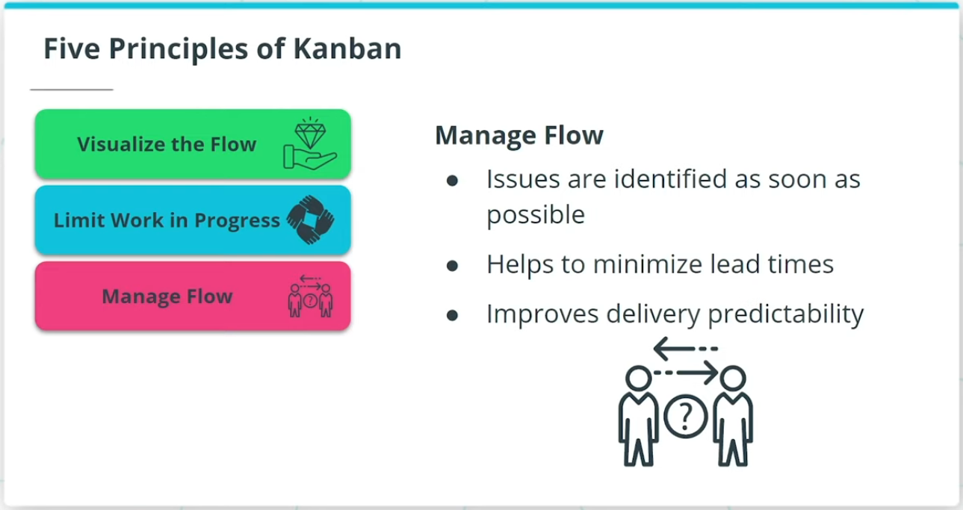

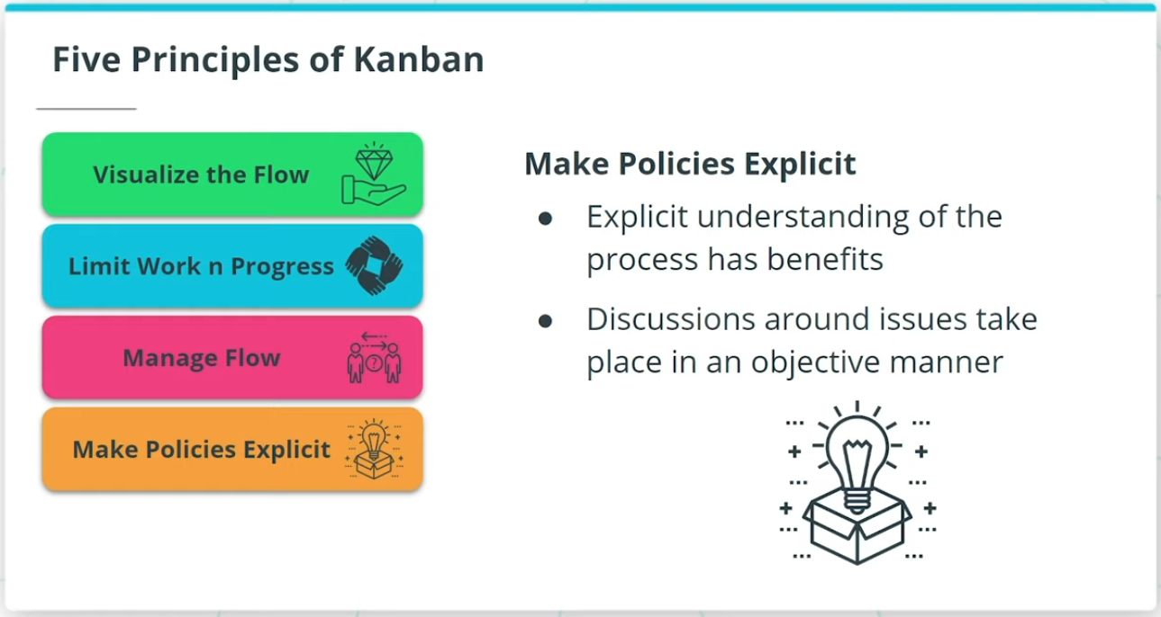

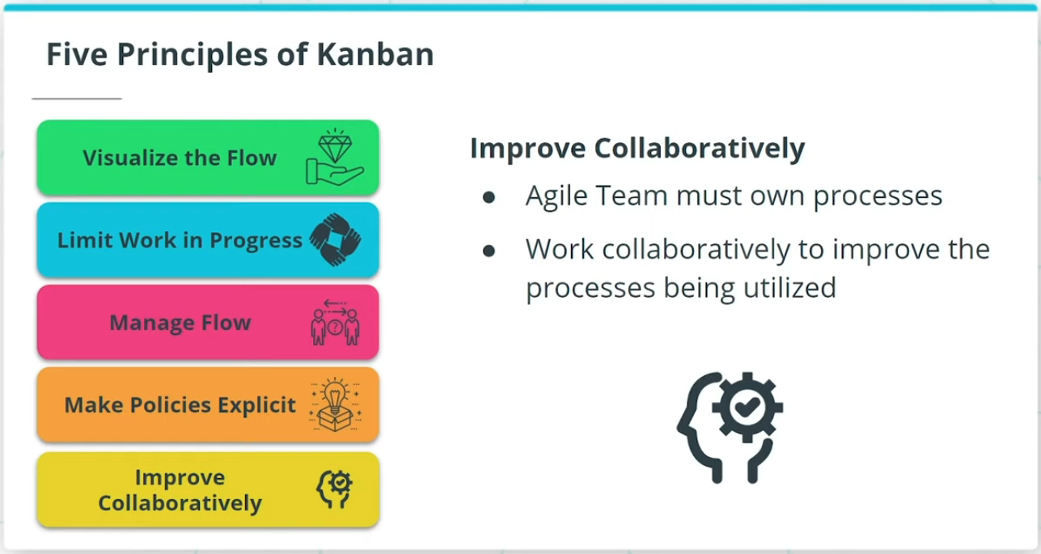

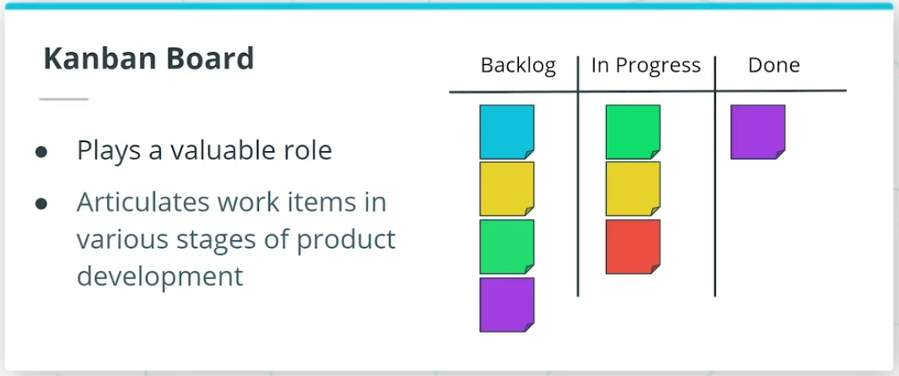

### **Kanban Framework**

Kanban has its origins in lean product development, an approach to product development inspired by lean manufacturing principles and practices at Toyota.

### **Kanban Framework**

Kanban has its origins in lean product development, an approach to product development inspired by lean manufacturing principles and practices at Toyota.

### **Lean Principles**

Lean product development focuses on 7 fundamental principles:

* **Eliminate Waste** - Anything that does not add value to the customer.
* **Build in Quality** - Lean focuses on good practices to ensure integrity and prevent defects.
* **Create Knowledge** - Lean encourages both training and peer-to-peer knowledge transfer.
* **Defer Commitment** - Lean recommends the Agile Team wait until the "last responsible moment" to make a decision, which allows for additional time to innovate.
* **Deliver Fast** - Lean encourages the Agile Team to create and deliver the product incrementally.
* **Respect People** - The Team must feel trusted and valuable to think and solve problems for themselves.
* **Optimize the Whole** - Lean encourages decreasing barriers to increase efficiencies by decreasing the amount of hand-offs and reducing WIP.

Lean Principles set the foundation for Kanban.

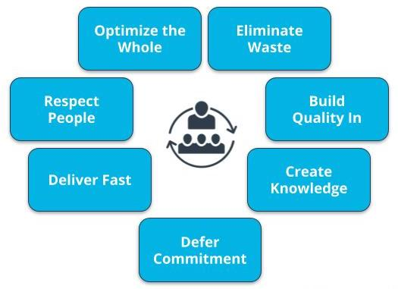

Lean Principles

Five Principles of Kanban

Kanban is a lightweight Agile Framework with 5 principles:

* **Visualize the Flow** - The Team visualizes the workflow, which helps in organizing, tracking, and optimizing the work.
* **Limit Work in Progress**- Limiting WIP helps to smooth the flow of work, reduce lead times, improve quality and delivery more frequently.
* **Manage Flow** - By Monitoring and measuring the flow of work, issues are identified as soon as possible, which improves delivery predictability.
* **Make Policies Explicit** - Establishing policies provides the Agile Team with explicit understanding of the processes for discussions around issues.
* **Improve Collaboratively** - The Agile Team must own the team’s work related processes and work collaboratively to improve the processes being utilized.

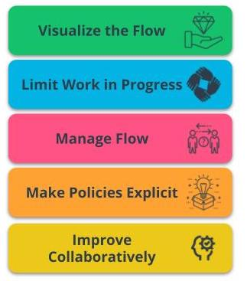

Five Principles of Kanban

A Kanban Board plays a valuable role as an information radiator since it shows the work items in their various stages of the product development journey.

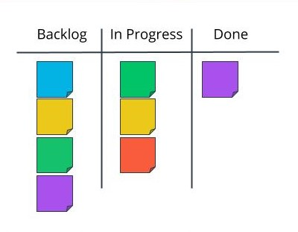

Kanban Board

Kanban Ceremonies, Core Roles and Artifacts

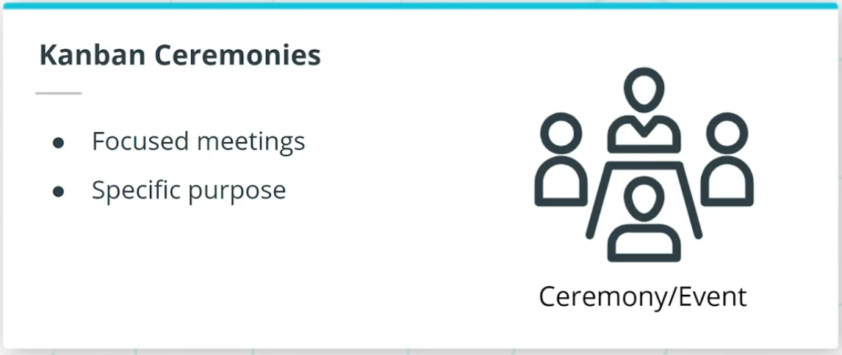

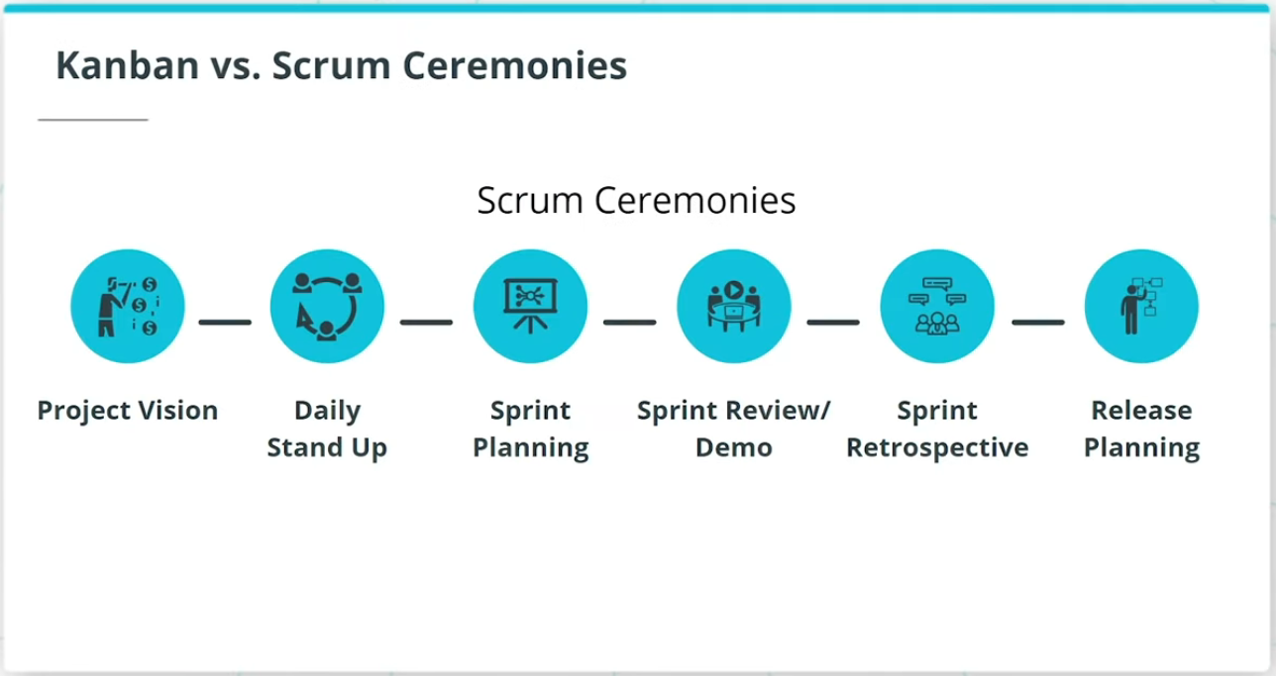

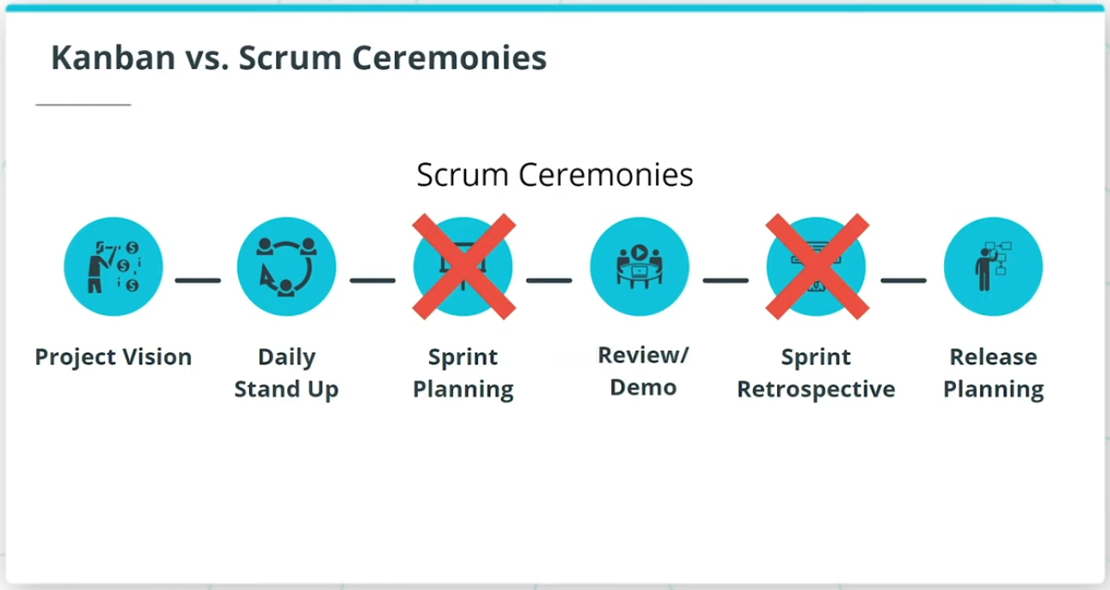

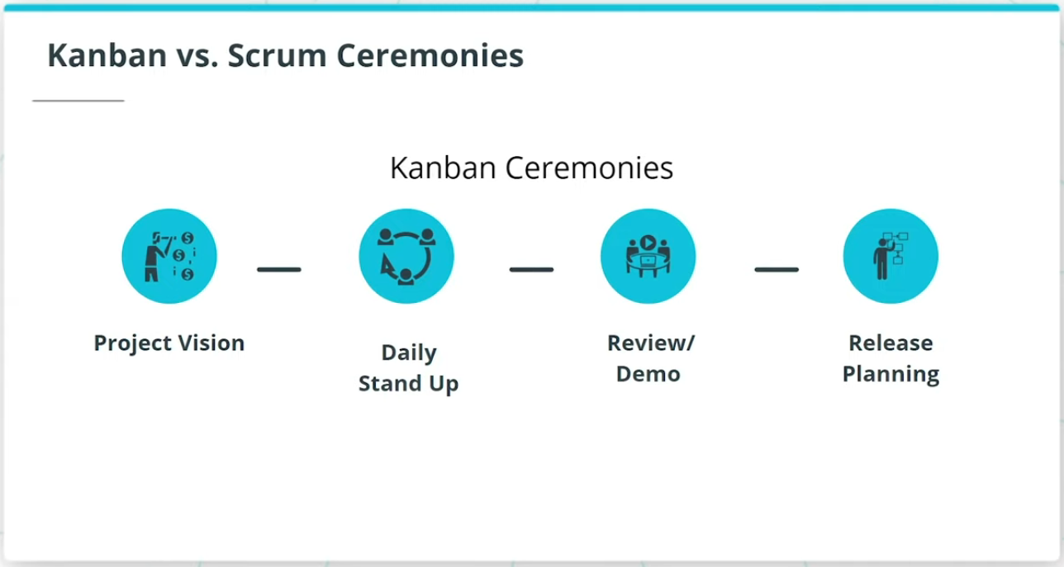

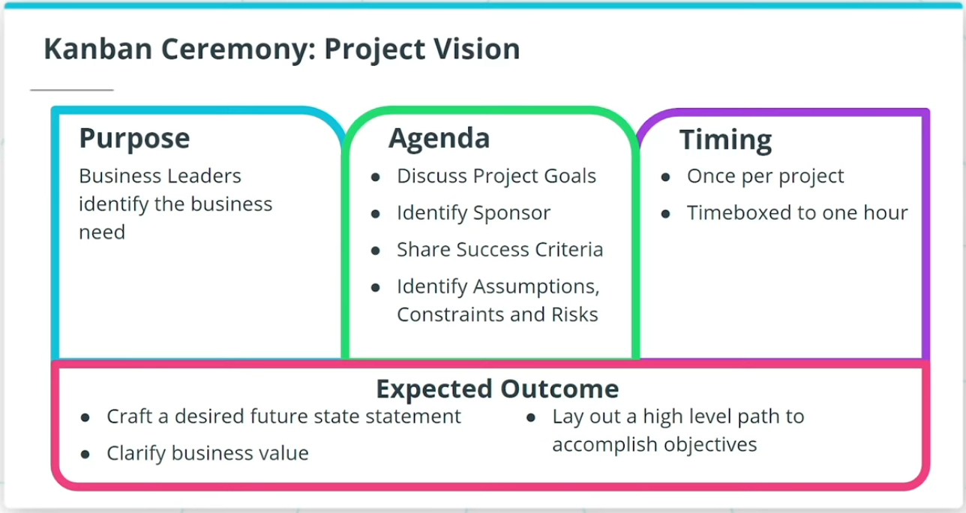

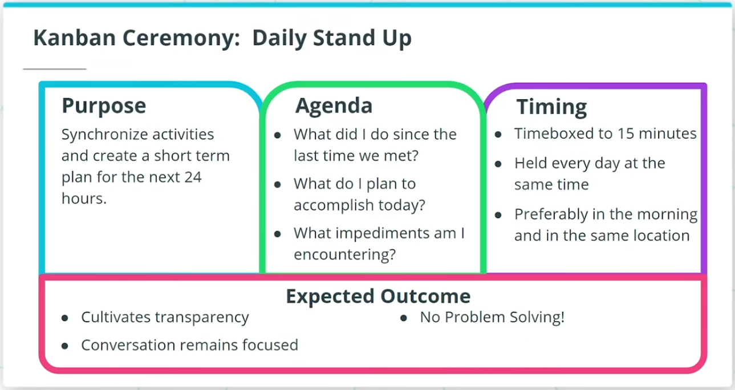

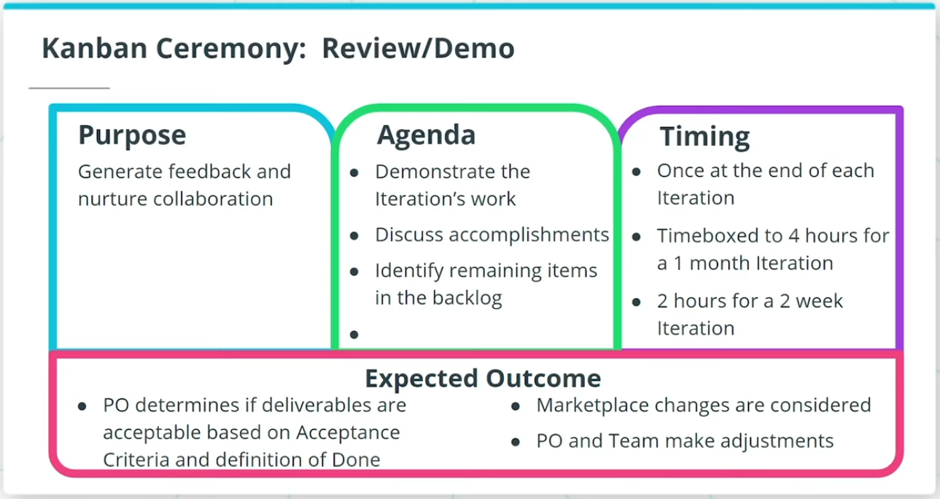

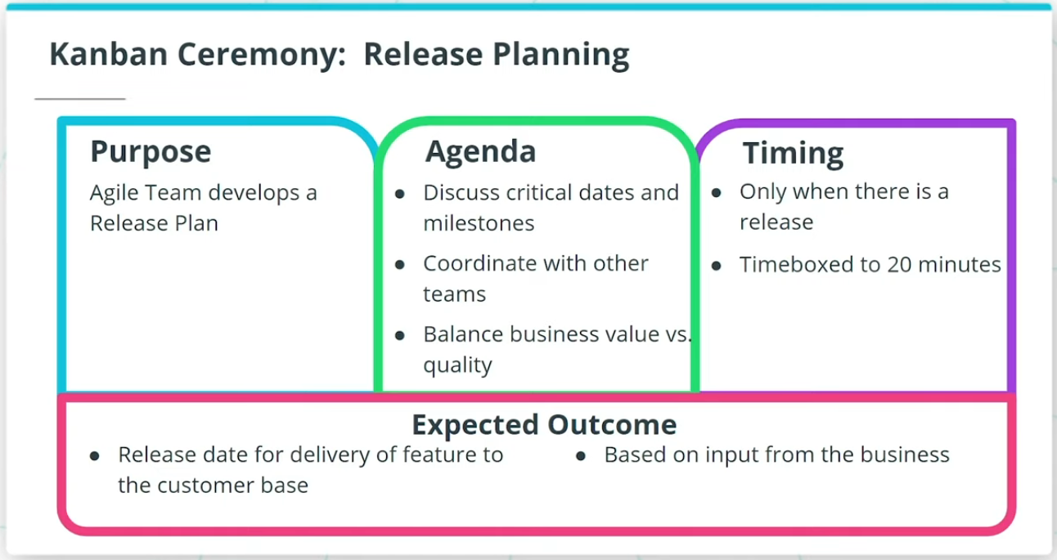

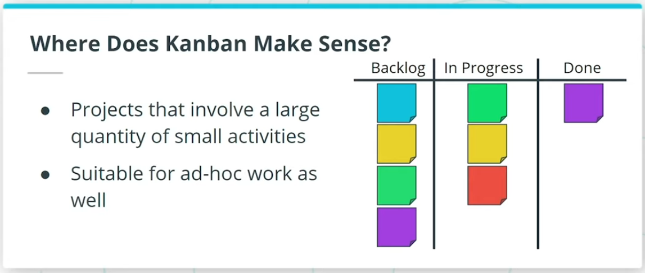

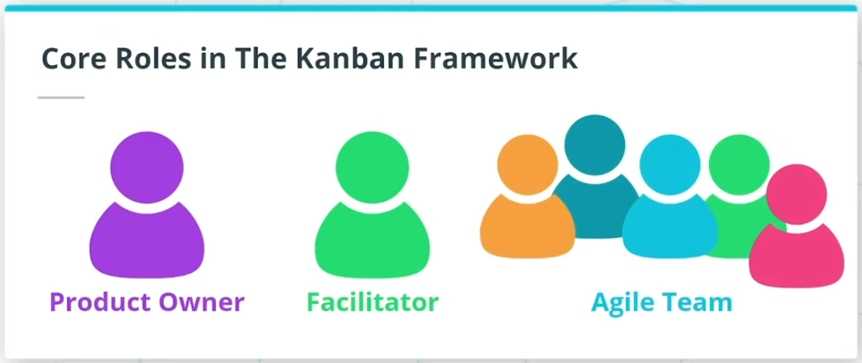

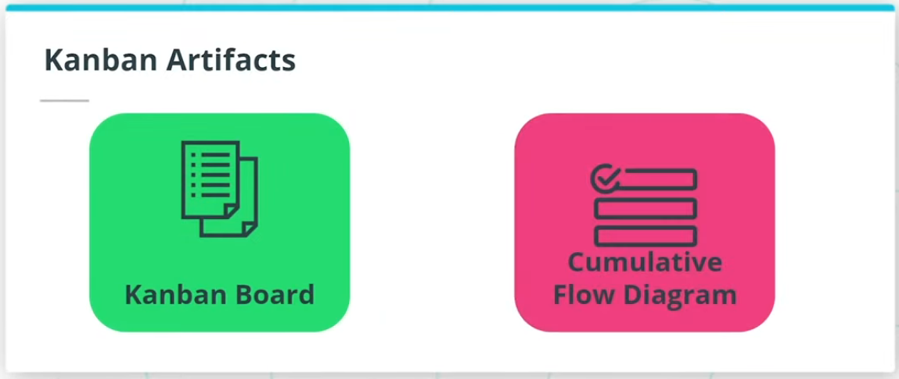

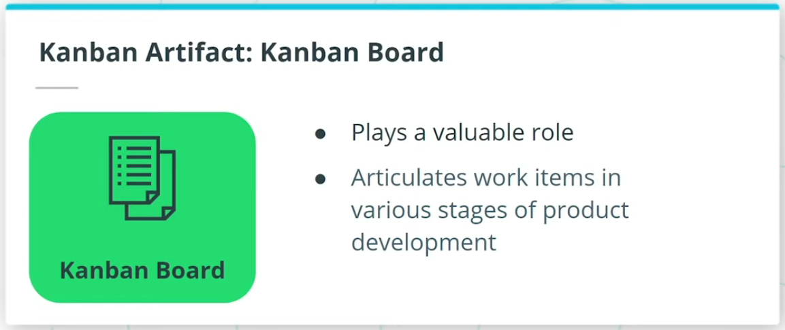

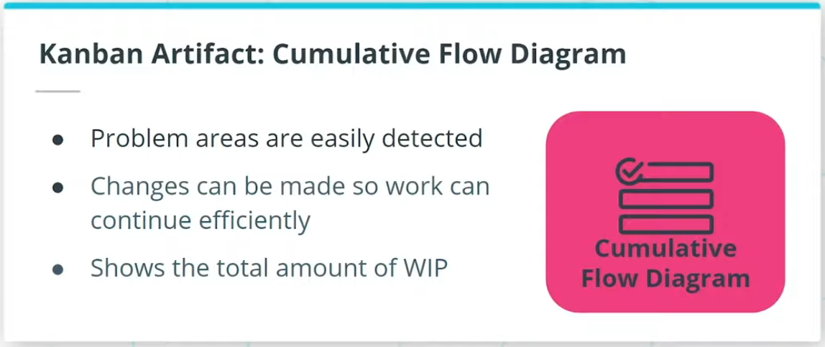

### **Kanban Ceremonies**

You will recall the 6 Scrum Ceremonies. In Kanban:

* The Ceremonies are simplified.
* There is no Sprint Planning Ceremony.
* And there is no Sprint Retrospective.
* Sprint Review/Demo is just called Review Demo.

So, the 4 Kanban ceremonies align with 4 of the Scrum ceremonies.

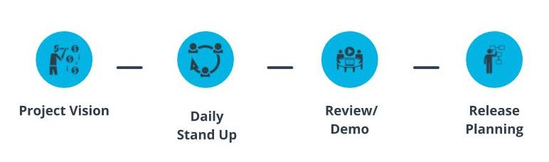

Kanban Ceremonies

### **Where Does Kanban Make Sense?**

* Since it focuses on the Agile Team’s workflow and throughput, Kanban is seen as a better Agile Framework option solution for projects where the work is likely to involve a large quantity of relatively small activities.
* Kanban is also suitable for work that may arise on an ad-hoc basis.

### **Kanban Roles and Artifacts**

### **Core Roles in Kanban**

* **Product Owner** - Seen as the voice of the customer.
* **Facilitator** - Team's Servant Leader.
* **Agile Team** - These are the resources that collaborate and work on the product deliverables.

### **Kanban Artifacts**

* **Kanban Board** - A Kanban Board plays a valuable role since it articulates the work items in their various stages of the product development journey.
* **Cumulative Flow Diagram** - A Cumulative Flow Diagram shows the total amount of WIP and how quickly projects are being completed.

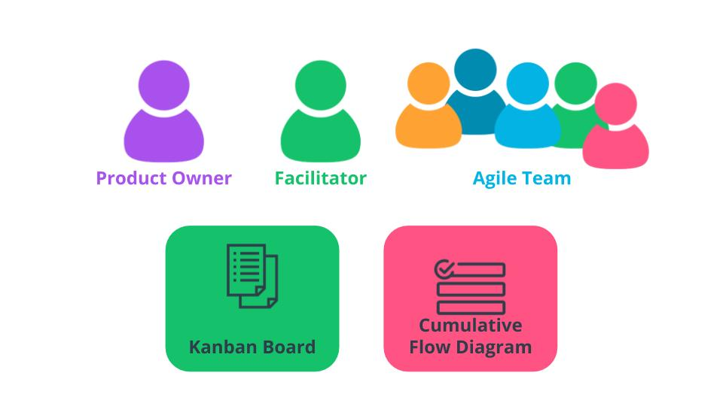

Kanban Roles and Artifacts

### **New Terms**

* **Cumulative Flow Diagram**: A diagram that shows the total amount of WIP and how quickly projects are being completed
* **Flow**: How work items in a process move through the various stages of development
* **Kanban Board**: A visual representation of the Agile team's work at various stages with a separate column for each stage
* **Kanban**: A lightweight Agile Framework that has its roots in Lean Principles
* **Lean Development**: A process to eliminate Muda by leveraging innovative solutions to reduce cycle time and cost

### **Additional Resources**

* [**Agile Alliance: Kanban(opens in a new tab)**](https://www.agilealliance.org/glossary/kanban/): Additional details on the Kanban Framework.
* [**Kanban at Blizzard Sport(opens in a new tab)**](https://prod-kanbanuniversity-backend-store.s3-us-west-2.amazonaws.com/case-studies/Blizzard-dist96.pdf): Blizzard Sports' case study shows the value of Kanban and its lightweight yet effective approach to delivering value.

# Quizzes: Kanban

## Thinking About Kanban

